Solent University

SCHOOL OF MEDIA ARTS AND TECHNOLOGY

**BSc Business Information Technology**

**2018 - 2019**

**Russell Neame**

***“In what ways can a progressive web application help raise awareness to university students on the latest scamming tactics?”***

Supervisor : Joe Appleton

**Date of submission : May 2019**

Acknowledgements

**Joe Appleton** – For his continuous support, improvement suggestions and invaluable advice offered throughout the whole project.

Abstract

University students can be seen as an easy target to scammers, especially when they are living away from home in an unfamiliar environment. In light of this, the following study explores the different ways a Progressive Web Application (PWA) can increase university student’s awareness on the latest scamming tactics. Participants were 5 university students, including 4 undergraduate students and 1 postgraduate student. Participants were asked to complete basic functions of the developed PWA during a usability test, which was followed up with one-to-one interviews. Interview recordings were then analysed, and themes were created from the data. Results suggested that a) the PWA’s features helped students build up a knowledge of different types of scams, b) new university students would see greater benefits using the application and c) the application could increase its effectiveness in raising awareness by adapting itself more around social media.

Table of Contents

**List of Figures** v

**Acronyms** vii

**1. Introduction** 1

**2. Literature review** 4

2.1 Students awareness of scams 5

2.2 Progressive web applications 7

2.3 Conclusion 9

**3. Project specification / Requirements** 11

3.1 Platform 11

3.2 Progressive web application requirements 12

3.3 Application features 12

**3.3.1 Prototype features** 12

**3.3.1.1 User posts** 12

**3.3.1.2 User log in / sign up** 13

**3.3.1.3 Push notifications** 13

**3.3.1.4 Offline functionality** 13

**3.3.2 Ideal feature** 13

**3.3.2.1 Search** 13

3.4 Wireframe 14

**4. Methodology** 15

4.1 Participants 15

4.2 Procedure 15

**4.2.1 Usability test** 16

**4.2.2 Interview** 16

4.3 Data analysis 17

**4.3.1 Step 1 – Familiarisation with data** 17

**4.3.2 Step 2 – Develop initial codes** 18

**4.3.3 Step 3 – Search for themes** 18

**4.3.4 Step 4 – Review themes** 18

**4.3.5 Step 5 – Defining and naming themes** 19

**4.3.6 Step 6 – Writing up** 19

4.4 Professional, legal and ethical issues 19

4.5 Project management 20

4.6 Artefact evaluation 21

**5. Implementation** 22

5.1 Features implemented 22

**5.1.1 Sign up / Log in** 22

**5.1.2 Create scamming post** 24

**5.1.3 Push notifications** 26

**5.1.4 App installation** 28

5.2. Technology choices 29

**5.2.1 Caching strategies** 29

**5.2.2 IndexedDB** 31

**5.2.3 Node package manager** 32

**5.2.4 Firebase** 32

**5.2.5 Material Design Lite** 33

5.3 Artefact reflection 33

**6. Results** 38

6.1 Artefact results 38

6.2 Interview results 39

**6.2.1 Social media** 40

**6.2.1.1 Using social media with scams** 40

**6.2.1.2 Social media characteristics** 41

**6.2.2 Findings scams easier** 42

**6.2.3 Warning new students** 43

**6.2.4 Features help increase scam knowledge** 44

**6.2.5 Lack of awareness** 45

6.3 Discussion 46

**7. Conclusion** 50

**8. References** 52

**9. Bibliography** 57

**10. Appendices** A-1

Appendix A – Instructions given to participants during usability tests A-1

Appendix B – Order of questions participants were asked during interviews B-1

Appendix C – 1st draft of codes and themes C-1

Appendix D – Re-draft of codes and themes D-1

Appendix E – Ethical clearance application approval E-1

Appendix F – Participant information sheet F-1

Appendix G – Informed consent forms G-1

**Participant 1** G-1

**Participant 2** G-2

**Participant 3** G-3

**Participant 4** G-4

**Participant 5** G-5

Appendix H – Trello board used to aid in managing the project stages H-1

Appendix I – Planned hours vs actual hours worked during project I-1

Appendix J – Google’s Manifest requirements to configure a custom splash screen J-1

Appendix K – Cross browser testing K-1

**Google chrome** K-1

**Firefox** K-2

**Opera** K-3

**Safari** K-4

Appendix L – Device tests L-1

**Mobile – iPhone 7** L-1

**Desktop – Macbook Pro 14inch** L-2

**Tablet – iPad Pro** L-3

Appendix M – Interview transcriptions M-1

**Participant 1** M-1

**Participant 2** M-7

**Participant 3** M-11

**Participant 4** M-16

**Participant 5** M-19

# **List of Figures**

Figure 1 - Wireframe of front page of the application 14

Figure 2 - User sign up screen 22

Figure 3 – Adding Firebase Authentication to the project 23

Figure 4 – JavaScript code used to sign in an existing user 23

Figure 5 - Scam post submission page 24

Figure 6 - Example of user scam post 25

Figure 7 – JS code used to upload the image file to GCS 26

Figure 8 - Notification banner displayed when the user subscribed to push notifications 26

Figure 9 - Notification banner displayed when a new scamming post had been added 26

Figure 10 – JS code used to state the notification settings and display the notification 27

Figure 11 - Desktop app installation prompt 28

Figure 12 - Installed application on Android mobile device and splash screen displayed on launch 29

Figure 13 - Cache then network strategy (Google 2019) 31

Figure 14 – IndexedDB database storing scamming posts 31

Figure 15 – JS code for background synchronisation of scamming posts 34

Figure 16 – JS code run when background sychronisation is not supported in the browser 35

Figure 17 – JS code that executes when no picture has been uploaded by user 36

Figure 18 – JS function used to convert image to a file 37

Figure 19 – HTML code that displays a splashscreen image depending on the size of the device 37

Figure 20 – Lighthouse audit results 38

Figure 21 – Progressive web app tests 39

Figure 22 – Thematic map displaying Main themes (blue) and sub-themes (orange) 40

Figure 23 – 1st draft of codes and themes during thematic analysis 1

Figure 24 – Final re-draft of codes and themes during thematic analysis 1

Figure 25 – Approval of ethical clearance at the start of the project 1

Figure 26 – Informed consent form signed by participant 1 1

Figure 27 – Informed consent form signed by participant 2 2

Figure 28 – Informed consent form signed by participant 3 3

Figure 29 – Informed consent form signed by participant 4 4

Figure 30 – Informed consent form signed by participant 5 5

Figure 31 – Trello board used for management of different tasks throughout the project 1

Figure 32 – Google chrome browser testing 1

Figure 33 – Firefox browser testing 2

Figure 34 – Opera browser testing 3

Figure 35 – Safari browser testing 4

Figure 36 – Testing the application on a mobile device (iPhone 7) 1

Figure 37 – Testing the application on desktop (Macbook Pro 14inch) 2

Figure 38 – Testing the device on tablet (iPad pro) 3

# **Acronyms**

**API** – Application Programming Interface

**CSS** – Cascading Style Sheets

**GCS** – Google Cloud Storage

**HTML** – Hyper Text Markup Language

**HTTPS** – Hyper Text Transfer Protocol Secure

**JS** - JavaScript

**JSON** – JavaScript Object Notation

**MDL** – Material Design Lite

**NPM** – Node Package Manager

**PHP** - Recursive “PHP: Hypertext Preprocessor”

**PWA** – Progressive web application

**REST** - Representational state transfer

**SNS** – Social Networking Site

**UGC** – User Generated Content

**UI** – User Interface

**URL** – Uniform resource locator

**UX** – User Experience

# 

# **1. Introduction**

In the United Kingdom, it has been estimated that scamming causes up to £10 billion worth of damage every year (Lonsdale et al. 2016). Today’s scams come in many different forms that are constantly changing, which makes it more difficult for people to detect what is legitimate and what is not (Nkotagu 2011). Scamming incident rates are not extremely high, however the financial and mental consequences caused by them can be devastating (Modic 2012).

Given the right design, scams can be extremely powerful, especially when anyone, regardless of age, can become a victim regardless of their individual characteristics and cognitive capacities (Pouryousefi and Frooman 2019). This goes against the common misconception that scams are only targeted at the elderly, which leaves little focus on the younger generation such as university students, who are faced with different types of scams (Samdahl 2013).

University students in particular are faced with a variety of scams which can have devastating effects, considering students are less likely to verify online information compared to people who are not students (Metzger, Flanagin and Zwarun 2003). Kleitman, Law and Judy (2018) highlight the importance of increasing awareness and competence when attempting to reduce susceptibility to phishing scams. One potential method of reducing people’s susceptibility to future scams is to forewarn them of the different types of scams (Scheibe et al. 2014). This could suggest that if students were made more aware of the latest scamming tactics, they are less likely to be susceptible to the different scams. In the past, technology has been used to raise awareness on different topics, such as social media being used as a tool to raise brand awareness (Qi and Mackie 2014). This creates the idea that a form of technology could be an effective tool in raising awareness to university students on the latest scamming tactics.

There are a number of different platforms that could be used including websites, web applications and native applications, however the selected platform would need to be able to function both on a desktop and mobile device in order to reach the maximum number of users as possible. One relatively new technology concept that allows this is a Progressive Web Application (PWA).

Progressive web applications have attracted a lot of attention upon their arrival and they are considered to represent an exciting concept in the evolution of the mobile web (Atar 2017). They are one of the most recent concepts to enter the website development industry and many companies are already adopting them (Majchrzak, Biorn-Hansen & Gronli 2018). In 2014, the number of people using the internet from their mobile device exceeded the number of users accessing it from their desktop (Chaffey 2018). This demonstrates that making any web application mobile friendly is becoming extremely important in order to maximise the reach of the application to its users because more people are using the internet on their mobile, so if an application does not provide this mobile experience, it is then reducing the numbers of users who can access the application. This therefore demonstrates that PWA’s ease of access across a wide range of devices can be an extremely powerful platform.

Combining an easily accessible platform with a problem that needs more awareness may help in reducing the costs, trauma and vulnerability caused by scamming. This is where the idea for a scamming progressive web application was formed. This study explores the use of a PWA to raise student’s awareness about the latest and most common scams that students are faced with. Providing this platform will allow users to post about their own scam experiences for others to read as well as search for scams they are suspicious about. The overall aim is that student’s awareness of different scams will have increased after use of the application.

To achieve the overall aim, a PWA has been created with the aim of raising student’s awareness to different scams. The PWA is an effective platform to engage with users and keep users revisiting the app due to a PWAs ability to be added to the user’s home screen which minimises the number of steps to re-engage with the applications content (Hume 2017). Installing the app does not require the user to go through an installation process like native applications, instead a simple click of the ‘add to home screen’ button is required. Another method to re-engage users is through PWA’s ability to send push notifications, which will send a push notification every time a new post has been added. This will help users keep up to date with the latest scams being posted. These methods combined with an easily accessible platform result in an important application that can help university students avoid the negative effects brought upon by scamming.

In this project, the different ways a PWA can help increase university student’s awareness on the latest scamming tactics were explored. A PWA was developed to allow users to post their own scam experiences and stories to help warn others. The developed PWA was tested by university students through usability tests and the students were then interviewed by the researcher to test how effective the PWA was as a platform in increasing university student’s awareness on the latest scamming tactics. Results of the qualitative enquiry suggest that the PWA is well received by students and could be effectively used to raise scam awareness. They also suggest that in order to increase its effectiveness further, it should be directed more towards social media.

# **2. Literature review**

Having outlined the importance of raising awareness on scams and the benefits a PWA can provide to users in the previous section, a literature review was conducted to explore university student’s awareness on different types of scams, as well as looking at PWAs in comparison to other technologies currently used today. It should be noted that due to PWAs still being a relatively new concept, there is a lack of literature currently available. As a result of this, scamming and PWA literature will be reviewed individually to show where this project fills a gap in the literature. The review will focus on scamming literature involving university undergraduate students from a variety of countries, and all available literature created on PWAs will be reviewed due to PWAs being a relatively new field of research.

Scams come in many different forms and they are constantly being changed to deceive the victim. While scams are believed to be targeted at the elderly, younger people are still vulnerable, as research shows that people under the age of 25 are more likely to be a victim of phishing scams (Sutherland 2014). Scamming is a method that has always been present, but due to scamming rates being estimated at under 10% on a yearly basis, the focus on raising awareness to it may not be seen as an important issue (Modic 2012). The elderly are considered to be more vulnerable compared to other age groups, however research has shown that people in theirs 20’s are more likely to lose money as a result of a scam compared to victims aged 70 or above (Federal Trade Commission 2017). University students tend to be a common target of the younger generation especially as they can seem more vulnerable when living away from parents. Nkotagu (2011) suggests that international students are more at risk, as a result of having little access to unlimited connectivity prior to joining overseas.

## **2.1 Students awareness of scams**

Numerous studies look into students’ awareness of different types of scams (Jones et al 2019; Nkotagu 2011; Baily, Mitchell & Jensen 2008; Kirwan, Fullwood and Rooney 2018). Regarding the levels of awareness university students possess when it comes to phishing scams, Jones et al (2019) explore how accurate they are at detecting which emails are legitimate or a scam. The participants included 224 university students and staff where they had to each examine 36 emails which included 18 non-phishing emails and 18 phishing emails. The study found that the average accuracy of the participants lay at 68%, with none of the participants correctly identifying all 36 emails, and only one participant guessing every phishing email correctly. These results show that the students were vulnerable to at least one scam, and that every student would be a victim of scamming in a real-life scenario. However, the email task is not entirely representative of a real-world scenario due to users being familiar with whom they interact with and will usually realise if an email sent to their inbox is relevant to them. This may reduce the validity of the results as it does not reflect the reality it claims to represent. In contrast to this, the task provides an ethically straightforward measure which is easily repeatable for future research.

A further study exploring awareness by Baily, Mitchell & Jensen (2008) looked into students’ awareness about different types of phishing emails. One-hundred and sixty undergraduate students were participants in this study, where they were asked to respond to a questionnaire which contained awareness and demographic data questions rated on a scale ranging from very likely (5) to very unlikely (1). It was identified that although students seemed to be well informed when it came to phishing emails regarding financial institutions requesting personal information, eighty- eight respondents lacked knowledge in emails using a URL masking technique. This study fails to indicate how participants were sampled during its research methods section, which reduces the reproducibility of this experiment for future research. Compared to this, Kleitman, Law and Judy (2018) do state how their participants were sampled in their study, which looks into students’ awareness to email phishing scams. Similar to previous studies (Jones et al 2019; Baily, Mitchell & Jensen 2008), this study used a 40-item email phishing detection task with 150 undergraduate psychology students. The detection task found that on average, 3 in 4 of the email items were detected accurately. However, the study also found a weakness in participants behaviour in that they hesitated to seek more information with the emails. Participants only sought more information 8% of the time for phishing emails, and 7% of the time for non-malicious emails. This study has higher levels of validity compared to the previously mentioned studies because its email detection task incorporates real world behavioural actions such as ‘keep it’, ‘trash it’ and ‘seek further information’. Including these real-world actions helps participants give a more accurate representation on how they would react in a real-world scenario.

Much of the above-mentioned literature focuses on phishing email scams, however Kirwan, Fullwood and Rooney (2018) looked at identifying the risk factors associated with scams related to Social networking sites (SNS). The study included 295 Malaysian undergraduate students whom each completed an online survey which consisted of SNS related questions to identify factors such as participants SNS usage, their perception of SNS scams and if they had been a victim of a SNS scam before. The study found 3 victimisation risk factors such as participants being on a SNS for a longer period of time, participants using fewer devices for SNS and participants having higher scores in impulsivity. Similar to this, Dhamija, Tygar and Hearst (2006) looked into university students and staff’s awareness to different fraudulent website scams. Participants were shown 20 websites in which they had to decide which ones were fraudulent. Results showed that incorrect choices were made 40% of the time. However, results also showed that there was no significant correlation between the number of hours that participants used computers and their score in identifying fraudulent website scams. This goes against Kirwan, Fullwood and Rooney (2018)’s finding that participants are more likely to be scammed if they spend longer periods of time on the sites.

A further study that looked into identifying phishing sites by Gavett et al (2017) explored into the suspiciousness of university students compared to older adults when detecting if a site is aimed at tricking users into entering sensitive information. The study used 193 participants, including 91 university students and 102 older adults which required them to perform numerous web browsing tasks such as websites login notifications and to rate each of the sites by their preference of style. Four websites were used, two were legitimate and two were phishing sites. Overall, the study found that the university students were the least effective in reporting suspiciousness to phishing due to having less experience and educational history in their lifetime with phishing compared to older adults. In contrast to these findings (Gavett et al. 2017), Dhamija, Tygar and Hearst (2006) argue that there is no significant correlation between ages and ability to detect legitimate and phishing websites. However, their study used 22 participants compared to Gavett et al (2017)’s 193 participants, which could suggest that having a significantly smaller sample size may lead to some inaccuracies in the data collected.

## **2.2 Progressive web applications**

PWAs are a relatively new concept which are an attempt to bridge the gap between native applications and web applications (Fransson and Driaguine 2017). In the past, previous attempts have been made to bridge this gap using web applications, however these attempts failed due to having no access to a device’s hardware such as the camera, geolocation and microphone which resulted in the inability to provide the same user experience (Steiner 2018). Traditionally, in the website development industry there has been three known types of applications to choose from when developing an application designed for a mobile device; these include native, hybrid and mobile web applications. However, PWAs introduced by Google in 2015 can now be considered another option to consider when developing a mobile application (Malavolta et al. 2017).

Due to PWAs being one of the more recent concepts to enter the web development industry (Majchrzak, Biorn-Hansen & Gronli 2018) they face a lot of comparisons to original technologies due to each option having different strengths depending on the project (Malavolta 2016). Current literature compares PWAs to alternatives such as native applications and cross platform developments, in which it states that one of the main advantages of PWAs is the minimal memory used on the user’s phone (Majchrzak, Biorn-Hansen & Gronli 2017). Fransson and Driaguine (2017) compared the performance of response times between a PWA and a native android application. The study tested both applications on 2 mobile devices (Huawei Honor 8 & OnePlus X) which measured the time taken to access the geolocation and camera hardware devices. The PWA was benchmarked using the web performance API (Application Programming Interface) and the native android application used Guava, a library made by Google. This study found that the native android application was far quicker in accessing the camera, however the PWA was faster in accessing Geolocation. This study has external validity issues as it only uses 2 mobile devices, which could produce entirely different results on other devices. In addition, this study has possible internal validity issues due to using two different benchmarks tools (Guava and web performance API) which use different programming languages which may affect the results of the benchmarks. Another aspect which looks at the differences of PWAs is Johannsen (2018)’s study which looks into the added complexity of making a web application ‘progressive’. The results suggested that implementing the different features to make a web application ‘progressive’ such as push notifications and service workers, does not greatly increase the complexity or size of the application. However, a possible limitation of this study is that technology is always updating and changing, so implementing a service worker in this study may be much more complex compared to a study in the future where different APIs or packages can be used to implement the same feature, in fewer lines of code. Therefore, this affects the reliability of the results.

To further understand how efficient PWAs are in relation to original technologies, Malavolta et al (2017) makes an interesting discovery whilst exploring into the effect of service workers on a PWAs energy efficiency. The study measured energy consumption for seven different PWAs on two devices (LG G2 & Lexus 6P) and two networks (2G and Wi-Fi). The findings showed that service workers had a negative impact on energy consumption, although it isn’t a significant impact overall. This suggests that service workers may potentially increase energy consumption if included in an application which is an important factor for mobile web developers when deciding between different approaches to use. This study shares the same external validity issue as Fransson and Driaguine (2017) in that only 2 android mobile devices were used which can affect the generalisation of the results to alternative android phones.

## **2.3 Conclusion**

This review aims to assess the awareness of university students to different scams and aims to compare PWAs as a platform against alternative technologies. The above-mentioned findings on university students and phishing emails demonstrates that although in some cases the majority of emails were detected correctly, there still remains gaps in student’s knowledge in terms of identifying phishing email scams. For example, in Baily, Mitchell & Jensen (2008)’s findings, 55% of students lacked knowledge about the email masking technique which suggests that these students are more likely to become victims of phishing emails using masked emails therefore demonstrating low awareness to this type of scam.

Overall the findings about PWAs suggest that they have slight differences compared to other technologies, some more beneficial, such as accessing Geolocation quicker, and some limitations such as accessing the camera. However, Johannsen (2018) and Malavolta et al (2017) demonstrated that although PWAs do add more code to an application and reduce the energy efficiency, these differences are not significant enough to be considered a limitation to PWAs. This shows that the decision to use a PWA as a platform for this study may result in more lines of code written, however a larger range of features will be able to be implemented as a result of this. Overall, Malavolta et al (2017) and Fransson and Driaguine (2017)’s studies could benefit from testing on a wider range of mobile devices, especially now that service workers are now supported by iOS. This is where this research study will be able to fill this gap in the literature and present the application on iOS.

# **3. Project specification / Requirements**

Having discussed what a progressive web application is and how it compares to other technologies in the previous section, this section states the rationale behind the decision of selecting a PWA as a platform to display scamming content and the reason why certain features have been included in the application.

## **3.1 Platform**

It was decided that a PWA would be a suitable platform for this project compared to a basic website due to its app-like feel, allowing university students to easily access the content from any device whilst also offering offline capabilities, added functionality and user experience (Majchrzak, Biorn-Hansen & Gronli 2018).

PWAs also benefit from the use of push notifications, which will be used to notify the user when a new scamming post has been added, which can help increase user engagement (Mhaske et al. 2018) and will increase the likelihood that the user will read the new posts therefore making them more aware to the latest scams being posted compared to a basic website which lacks these features. In addition to this, PWAs also give users the option to add the app to their home screen, which reduces the number of steps the user takes to re-engage with the app compared with a basic website therefore making the scamming content easier for university students to access.

## **3.2 Progressive web application requirements**

For this application to be considered a baseline ‘Progressive’ web application, it should meet each requirement of Google’s recommended PWA checklist (Google 2019)

* “Site is served over HTTPS
* Pages are responsive on tablets and mobile devices
* All app URLs load while offline
* Metadata provided for add to home screen
* First load fast even on 3G
* Site works cross browser
* Page transitions feel like they don’t block on the network
* Each page has a URL”

## **3.3 Application features**

This section lists the different features that were planned for the application and the benefits each feature could offer a university student when using the application. The features were decided through reviewing the literature and identifying features that would allow students to easily highlight a particular scam, as well as increase their knowledge of scams university students face over time.

### **3.3.1 Prototype features**

#### **3.3.1.1 User posts**

This feature will allow users to post their own scam experiences, warnings or suspicions. This feature also encourages new content to be posted by users, which will be the main content viewed by all users. User generated content (UGC) can help in building a community and raising awareness to different topics such as scamming (Krumm, Davies and Narayanaswami 2008). Giving users the ability to post content helps them provide information to other users which can then increase the awareness of other users on the particular scam posted about.

#### **3.3.1.2 User log in / sign up**

User authentication will be an included feature in order to identify which user wrote each scamming post. Creating an account will be a mandatory function before a user can create a scam post of their own.

#### **3.3.1.3 Push notifications**

Users will have the ability to subscribe to push notifications, in which they will be notified every time a new scamming post has been added. This feature is extremely important as it will encourage users to read the latest posts, therefore increasing their engagement with the app (Kim 2014).

#### **3.3.1.4 Offline functionality**

The application will still display its content when the internet connection is lost, and if the user submits a post when the connection is down, this post will be stored and posted as soon as a connection is found. This functionality will ensure that university students will still be able to read through content regardless of their internet connection status and it will improve the user experience as a whole (Google 2019).

### **3.3.2 Ideal feature**

#### **3.3.2.1 Search**

A search feature will be included which allows the users of the application to search different keywords, which will bring up different posts submitted by users about scams that contain that searched keyword. This will aid users in finding specific scams they are interested in finding more information about.

## **3.4 Wireframe**

Figure 1 - Wireframe of front page of the application

The project specification features were transformed into a wireframe to visualise a basic design for the application and to plan how each required feature would be presented in the application. A wireframe was chosen since they can help keep a consistent idea of the design of the application and help identify problems in the earlier stages of the project (Garrett 2010). This helps reduce any confusion as to where certain elements should be placed and how specific features may function.

# **4. Methodology**

This section focuses on outlining the framework used to explore whether the features listed in the previous project specification section are effective in increasing university student’s awareness on scamming. Key decisions related to the research study will be explained here and the process of testing the developed PWA will be identified.

## **4.1 Participants**

For this research study, purposive sampling was used to gather participants, in which a total of 5 university students (4 males and 1 female) were used. This sample size was decided upon due to research suggesting that qualitative studies gather between 5 and 25 participants (Creswell 1998). Due to the size of this project and limited time, 5 participants were chosen from this sample range. The criteria used in selecting participants was that every participant should be enrolled on any course subject at any university. Purposive sampling was chosen to help ensure that individuals met the specific criteria (Palys 2008), therefore keeping the study relevant to the project’s aim. The participants selected were all enrolled on different types of courses across 3 different universities. Four of the participants were third year undergraduate students, one participant was a postgraduate student and the mean age of the participants was 22.4, ranging from 22 to 24 years.

## **4.2 Procedure**

At the outset of this study, participants were given an information sheet to read which explained the aims of the study they were participating in and what they could expect during it, and they then provided informed consent. The study asked participants to undertake a usability test of the developed scamming PWA in which they performed basic functions of the application, and then the researcher gave a demonstration on other functionalities of the application to help give them a better understanding of how the application works. Following this, participants were then asked a series of questions during their one-to-one interviews with the researcher. Participants were assessed individually instead of assessing all participants at once in order to reduce the chances of missing issues or observations in a group setting due to so much happening simultaneously (Downey 2007).

### **4.2.1 Usability test**

Participants were shown the developed PWA on both a desktop (MacBook) and mobile device (iPhone and Android). First of all, participants were asked to complete a set of basic functions of the application in order for them to gain a better understanding of how the app works. These instructions can be seen at Appendix A**.**

The researcher then demonstrated other features of the application that make it a PWA such as navigating around the application without an internet connection, submitting a scamming post without an internet connection and installing the application on a mobile device (Android and iPhone). This was done to help participants distinguish how the PWA is different from a basic website.

### **4.2.2 Interview**

Following the usability test, participants then had one-to-one interviews conducted by the researcher. Interviews were recorded to make sure no details were missed, and difficulties are prevented later in the research process (DiCicco-Bloom & Crabtree 2006). For the interviews a structured approach was taken, meaning all participants were asked the same set of questions. This approach was chosen to help reduce interviewer bias as the element of ‘interviewer judgement’ is removed (Kutcher and Bragger 2004) and participants answers can be more easily compared. To further reduce research bias, open ended questions were asked during the interview to prevent steering participants to endorse a particular response (Mehra 2002).

Participants were asked questions of which the aims were getting an understanding of their opinion is on the application itself, if the application has made them more aware of scams that university students face and if they believe it is a suitable platform to help raise awareness to university students in the future. The set of questions asked can be seen at Appendix B.

## **4.3 Data analysis**

Participants responses to the interview questions were analysed using thematic analysis. Thematic analysis was chosen as a method for data analysis because it can help summarise the keys features of the data, as well as providing an overall description of the data set (Braun and Clarke 2006). Thematic analysis is a widely used method that has formed different approaches (Braun et al. 2019), so it should be noted that for this study, Braun and Clarke (2006)’s 6 step approach was followed as it provides a clear and usable approach to performing thematic analysis. For this study, a theoretical thematic analysis was used since data was analysed with the specific research question in mind, this made analysis a more effective process because codes were only identified if they highlighted something interesting or important to the research question.

### **4.3.1 Step 1 – Familiarisation with data**

To analyse the recorded data, each interview recording was transcribed for further analysis and to gain a better understanding of the data (Riessman 1993). Transcripts were read through multiple times which helped give an overall view of what potential codes there are.

### **4.3.2 Step 2 – Develop initial codes**

It was decided that open coding would be used, meaning that codes would be generated during interpretation of the data analysed, therefore no predefined codes were created before analysis as there is no distinct theory being tested during this study (Creswell and Creswell 2018). Codes were also manually generated as opposed to electronically due to the small collection of data so using software tools was not necessary. The generated codes were a short descriptive phrase or sentence about the data highlighted, which were identified if they provided an interesting or important point in relation to the research question. Throughout this step, codes were added, removed and renamed as transcripts were re-analysed.

### **4.3.3 Step 3 – Search for themes**

Once the codes had been completed, they were reviewed to form overall themes that describe one or more of the codes (see Appendix C). The themes created described the overall patterns of the dataset in relation to the research question. For example, there were multiple codes about participants not knowing about certain scams as well as codes about knowing one particular scam. These types of codes formed a theme called ‘Lack of awareness’.

### **4.3.4 Step 4 – Review themes**

During this phase, themes were re-analysed by comparing them to the transcription data and checking that they gave meaningful, accurate descriptions of the data. This step helped modify theme names and create sub-themes when codes related but had slight differences (see Appendix D). Here, codes were discarded if they didn’t relate to any themes and if a meaningful theme could not be generated from them. It also helped highlight that some codes could be applied to multiple themes which helped show a relationship between the themes. Once this step has been finalised, a thematic map was produced to help display each of the themes, sub themes and their relationships between one another.

### **4.3.5 Step 5 – Defining and naming themes**

This step was the last refinement of the themes where we planned on “identifying the ‘essence’ of what each theme is about” (Braun and Clarke 2006). This helped identify how themes related to one another and looked at explaining how sub-themes have emerged and how they interact with their main theme. To ensure themes were suitable for the research question, each theme was summarised in a couple of sentences. If it was difficult to summarise and explain a theme in relation to the research question it would need to be further refined.

### **4.3.6 Step 6 – Writing up**

Once all the themes had been finalised, a final analysis of them explained an interesting account of what the data told and how the themes interlinked. The analysis was supported by evidence provided from the transcripts and each of the themes were related to the research question.

## **4.4 Professional, legal and ethical issues**

Before work could begin on this project, an ethical release form was completed (see Appendix E) which checked if participants will be used and what effects the research study could have. During the data collection stage of this project where participants were involved in usability tests and interviews, different ethical principles were abided by. Firstly, before participants could take part, they were each given a participant information sheet to read (see Appendix F), which outlined what the research study was about, what it’s aims were and what they could expect during the study. Next, participants were handed an informed consent form to sign (see Appendix G), which confirmed that the participants had had the ethical principles explained to them, such as having the right to withdraw at any time in the study without giving a reason, how their data will be analysed, stored and published, and permission to record their audio during the study.

## **4.5 Project management**

Various areas of the project had to be monitored continuously from planning appropriate time frames to conducting usability tests through to the development of the application. Throughout the project, code was constantly being updated, removed and added to when implementing new features of the application which posed risks, such as existing features of the application functioning incorrectly due to errors in the code. The risk of this was reduced by using a version control system called Git. Here, a feature branch strategy was used in order to keep a full working version under the ‘master’ branch, so that when new features were added such as ‘Notifications’, a new branch could be made to make these changes and once the notifications were working correctly, this branch could then be merged into the master branch which would result in all the features functioning correctly. Therefore, if a mistake was made in the code, it was possible to revert back to the original master branch with the original working version of the application.

The project management tool Trello was used to help with managing deadlines for different stages of the project (see Appendix H). Project management was effective using Trello because every deadline set was met on time and divided tasks had a clear order of completion. Appendix I shows the estimated hours worked compared to the actual hours worked on the project. From this it shows that each stage of the project was completed within the planned hours allocated to it. This demonstrates effective time management throughout the process, which resulted in no tasks overrunning and affecting the time available for other tasks.

## **4.6 Artefact evaluation**

Once development on the application was complete, Google’s auditing tool ‘Lighthouse’ was used to evaluate the developed PWA to produce quantitative data as well as to help identify ways in which the application can be improved (Google 2018). The PWA’s URL was input into Lighthouse which produced different metrics about the application such as accessibility, progressive web app score and performance. This method was chosen as the quantitative data produced could then give a measurable indication of how successful the development on the application was, which could then also be compared to competitors and other progressive web applications.

# **5. Implementation**

Before proceeding to examine the results of the methodology, this section will outline the different features implemented in the application which were presented to participants, the rationale behind some of the decisions made on technical aspects of the application and an overall reflection on the process of implementing the PWA.

## **5.1 Features implemented**

This section displays the different features with screenshots giving an insight into which screens of the application participants viewed during usability tests and how they were implemented.

The source code of the application can be found at: <https://github.com/russellneame/studentScams>

The final version of the application can be accessed from its hosting URL:

<https://studentscams-8639d.firebaseapp.com/>

### **5.1.1 Sign up / Log in**

Users can sign up for an account on the application which also allows them to sign in to an existing account which is required in order for users to submit a scamming post (Figure 2).

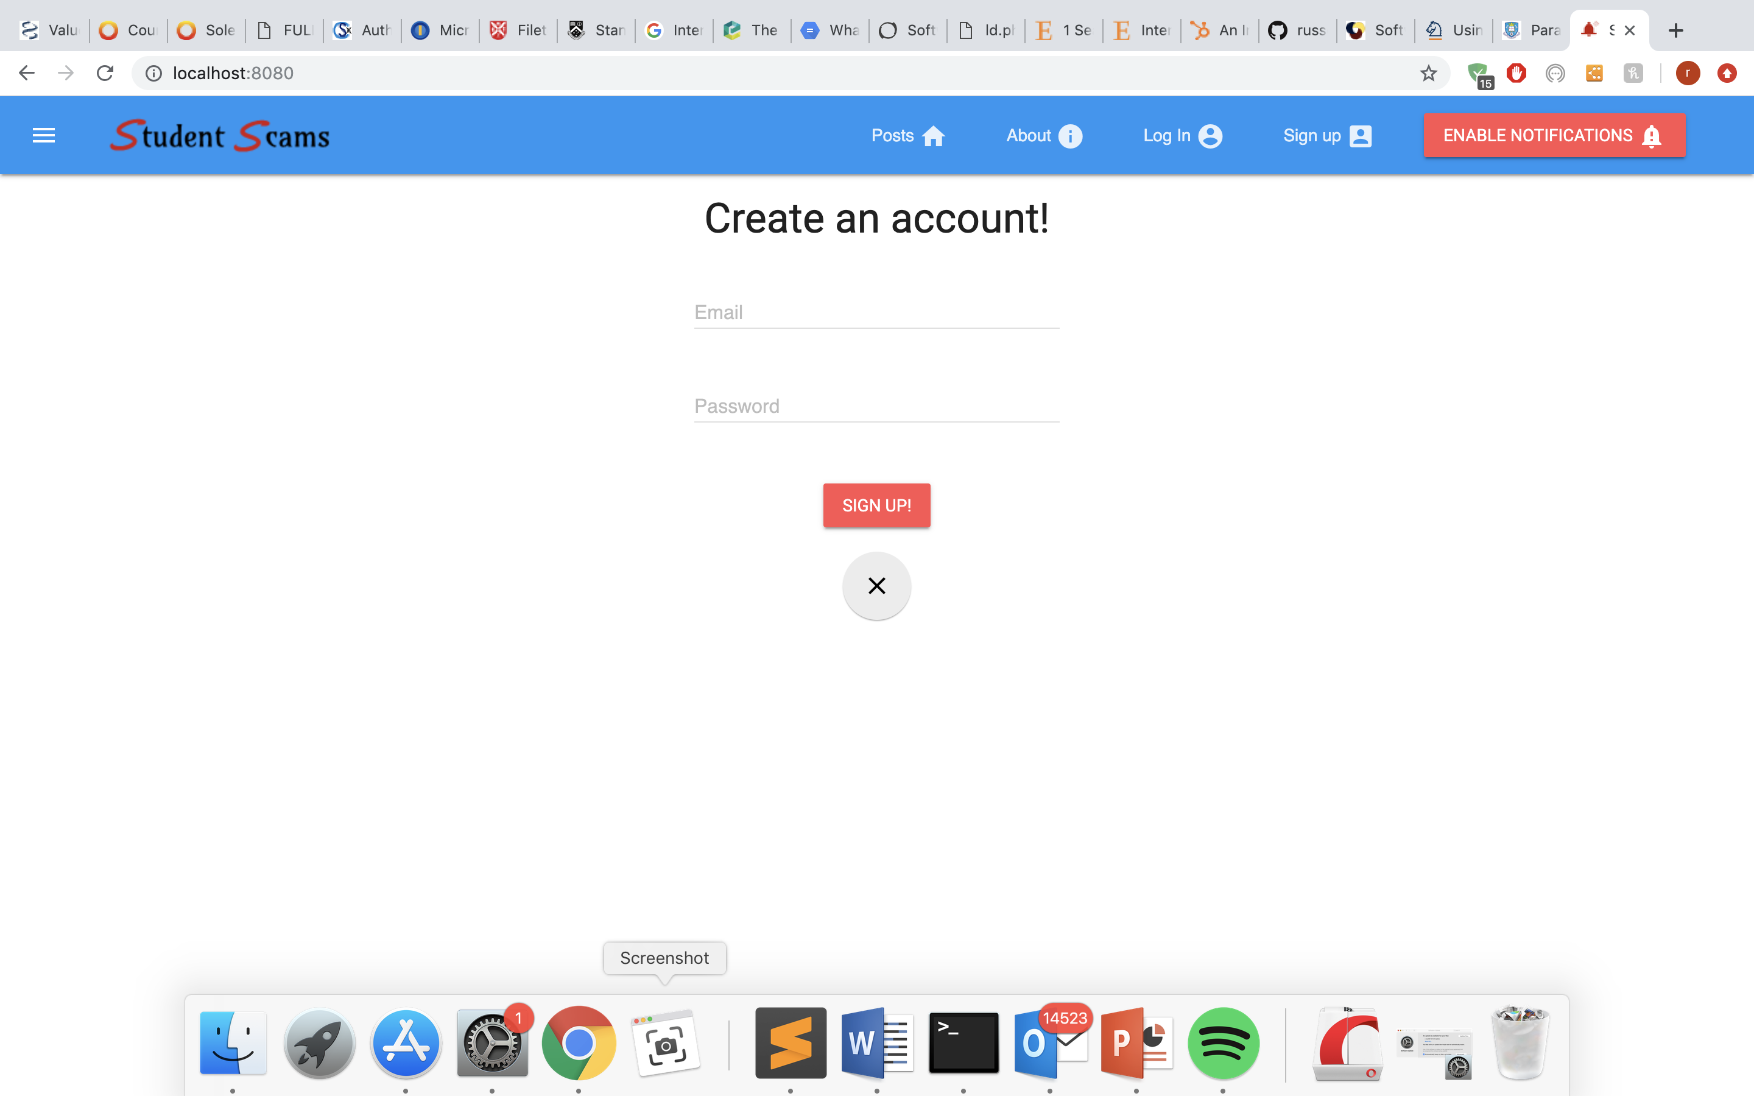

Figure 2 - User sign up screen

This functionality was achieved by using Firebase authentication. Firebase authentication was added to the application which defined different keys related to the project and initialized a firebase app instance (Figure 3).

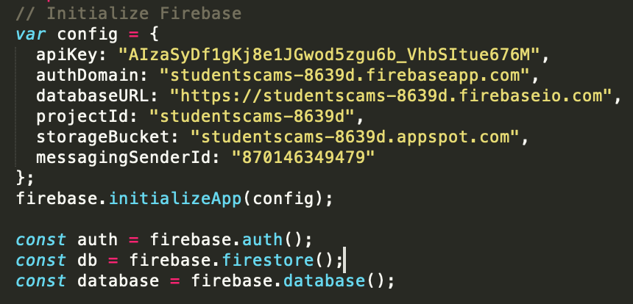

Figure 3 – Adding Firebase Authentication to the project

Once the user had submitted their details, the sign up or log in form details were then passed to firebase methods called ‘createUserWithEmailAndPassword’ and ‘signInWithEmailAndPassword’ which both accepted two parameters: email and password. These methods returned a promise which returned the user details if the log in or sign up process was successful (Figure 4). When the user credentials were sent to Firebase, they were exchanged with a firebase token ID and a refresh token which were used to manage user sessions. These tokens were only deleted when the user signs out.

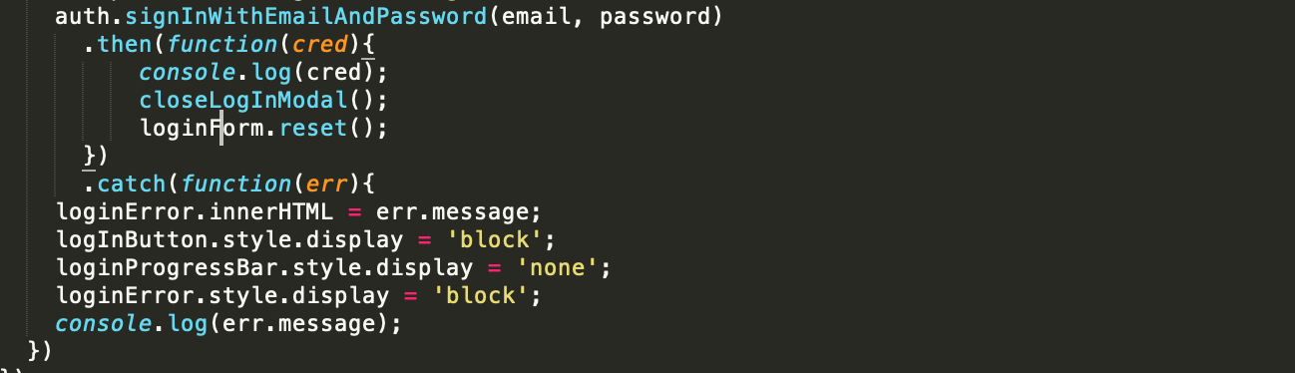

Figure 4 – JavaScript code used to sign in an existing user

### **5.1.2 Create scamming post**

Once signed into an existing account, users of the application can submit a post about a scam which creates the content of the application. Here, a camera feature allows the user to take a picture using the front facing camera on a desktop, or both the front facing and back facing cameras on a device that provides two cameras. (Figure 5).

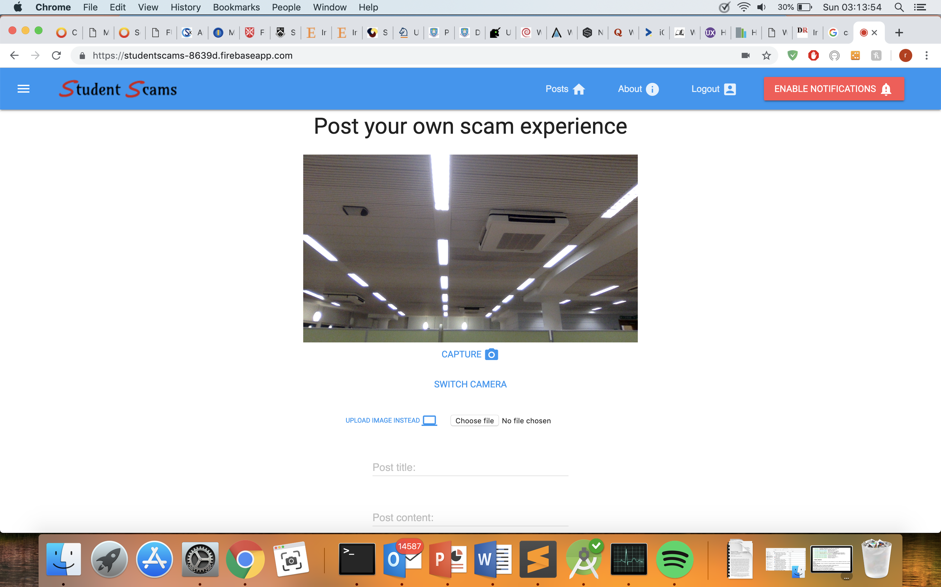

Figure 5 - Scam post submission page

Alternatively, the user can upload an image from their files instead. Users can then write a title, content and location about their particular scamming experience or story and submit this post for all other users of the application to view. The details are then presented on a material design lite (MDL) card displaying all of the user submitted details, as well as the user’s email address and the date the post was submitted (Figure 6).

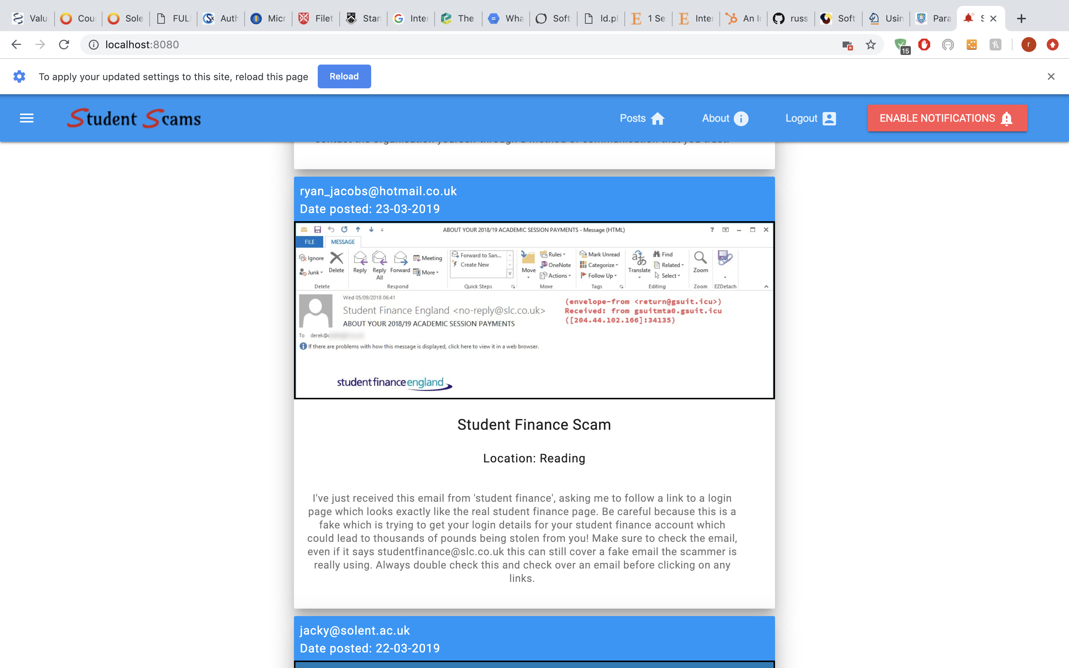

Figure 6 - Example of user scam post

This was implemented by taking the details entered from the user and firstly checking if the browser supports service workers and the syncManager API. If both conditions are supported, the user data is stored in IndexedDB object store ‘background-sync-posts’ which returns a promise. In this promise, the data is then attached to a ‘sync’ event, in which the service worker will be listening for this event. Once triggered, the service worker will loop through all the posts in the ‘background-sync-posts’ and send a ‘POST’ request containing this data to the firebase cloud function created called ‘storePostData’. If the browser does not support service workers or the ‘syncManager’ API then the fall-back function skips all indexedDB steps and posts the data to the firebase cloud function as previously stated.

The node.js module ‘busboy’ was used to automatically parse the data posted. The image is uploaded to Firebase’s cloud storage by referencing the bucket to upload it to (Figure 7). The data is then inserted into the firebase database using the ‘push’ method and referencing the parsed fields.

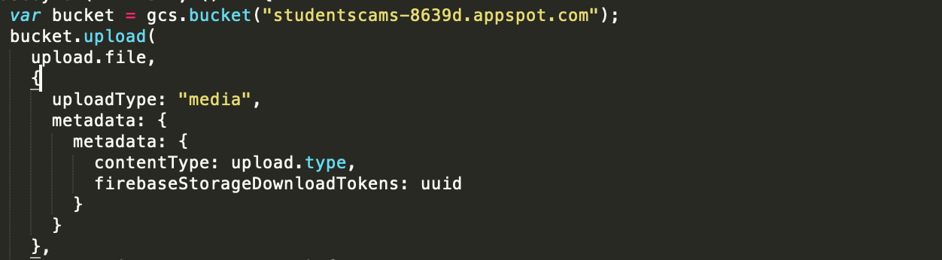

Figure 7 – JS code used to upload the image file to GCS

### **5.1.3 Push notifications**

Users can subscribe to alert them when a new scam post has been added (Figure 8). Once subscribed, they will receive a push notification every time a new scam post has been added to the application (Figure 9).

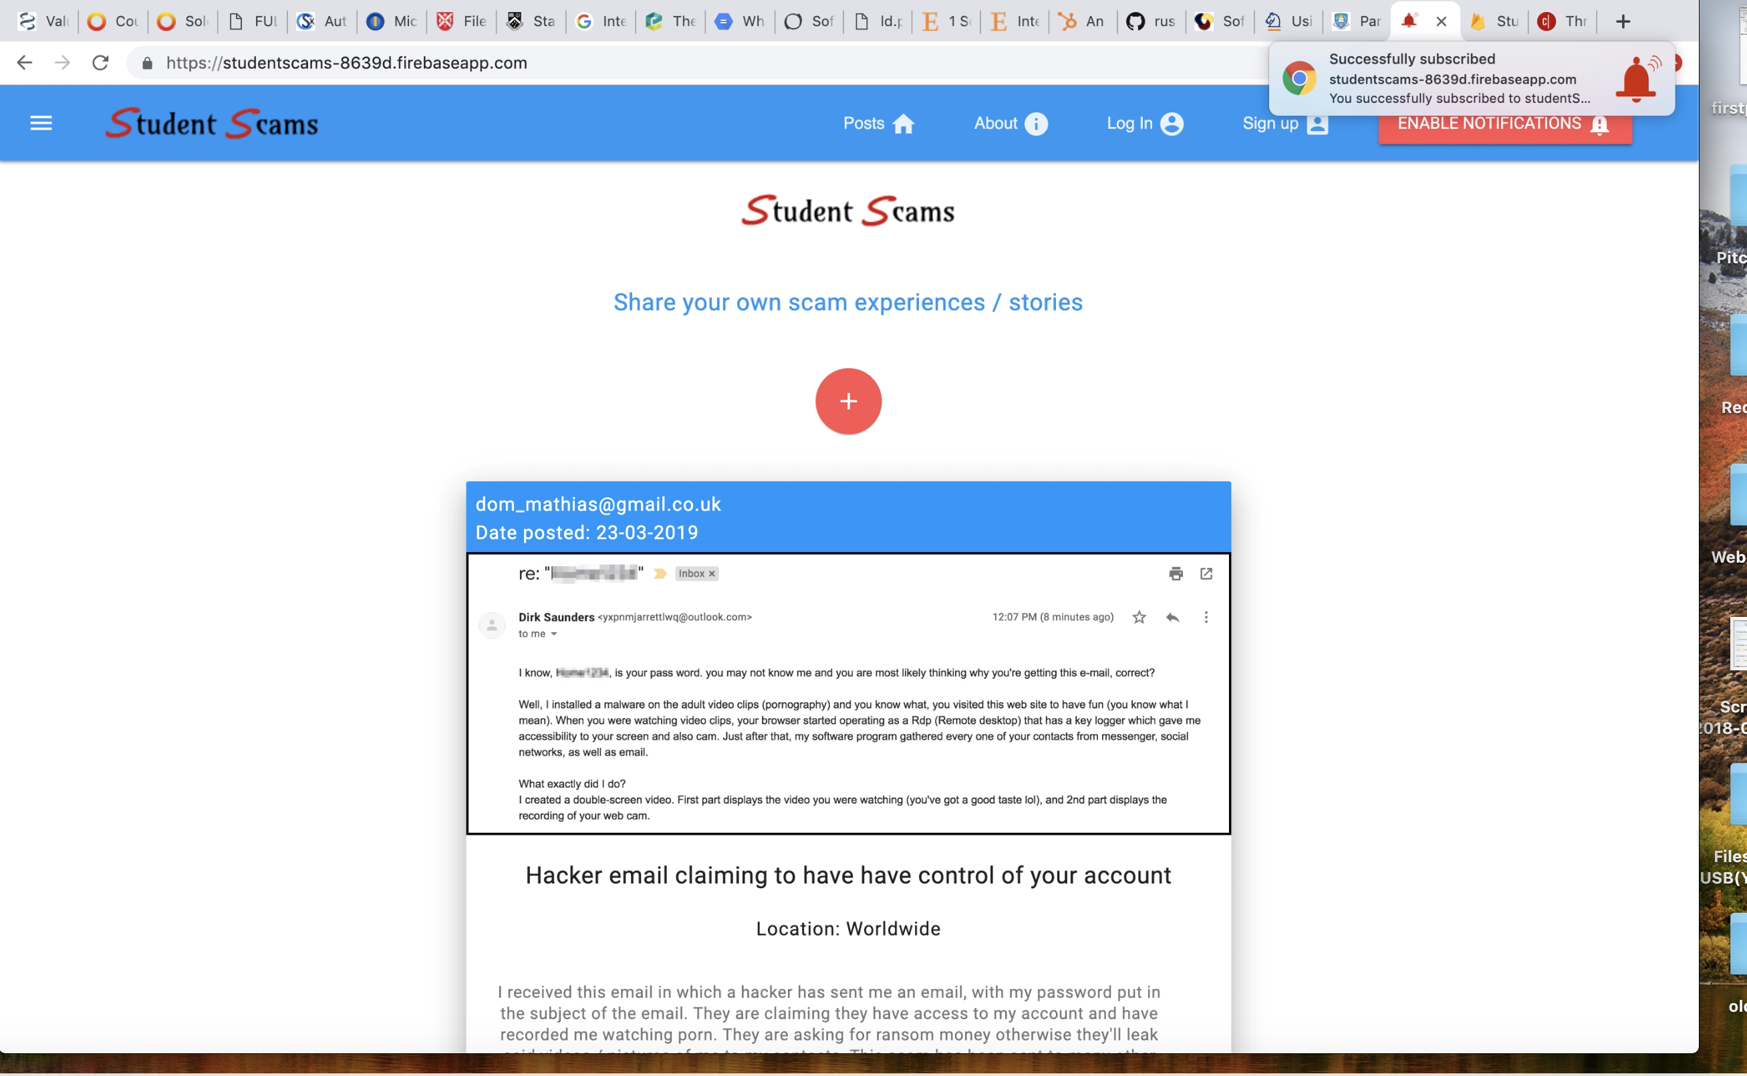

Figure 8 - Notification banner displayed when the user subscribed to push notifications

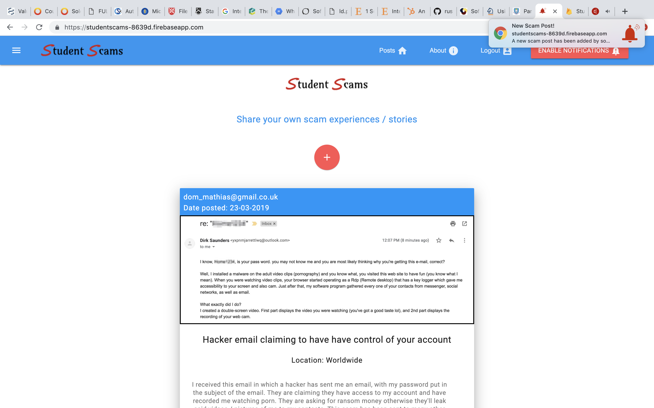

Figure 9 - Notification banner displayed when a new scamming post had been added

To display the notification when a user has subscribed, first it was checked if the user was already subscribed to notifications using the method ‘getSubscription’. If no subscription was found, then an application public server key (generated using web-push) was converted to base64 and passed as a parameter in the method ‘subscribe’ which was called on the ‘pushManager’ API which subscribed to the push service. Once subscribed, the subscription was stored in the subscriptions database using a fetch POST request. After completing the post request, an object was created to list all the different options of the desired notification such as the title, icon displayed, vibration setting, and the actions displayed on the notification. This object was then passed to the service worker which called a method called ‘showNotification’ which created a notification on the active service worker and resulted in a notification displaying to the user (Figure 10).

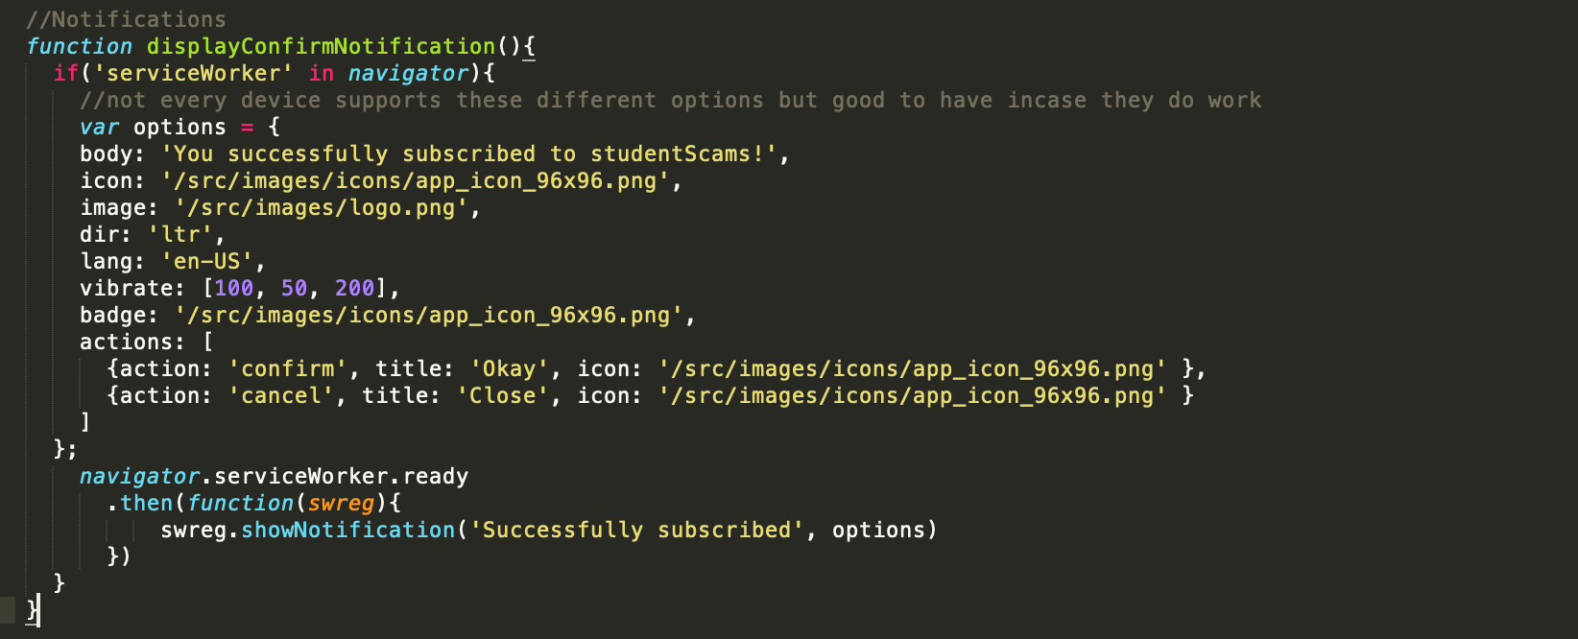

Figure 10 – JS code used to state the notification settings and display the notification

Displaying a notification every time a user had posted was achieved by attaching a promise onto the process of submitting a post. Therefore, this would run every time after a post had been created. Notifications were sent by firstly using the ‘setVapidDetails’ method which checked the public and private keys generated by web push. This was done to authenticate notifications and to ensure no users could send notifications themselves due to the private key being hidden in server-side code. The notifications were then sent by looping through every subscription stored in the database and using the ‘sendNotification’ method which took the subscription as one parameter, and the data which will be displayed to the user as the other parameter.

### **5.1.4 App installation**

Users of the application are prompted to install the app when they click the red plus sign which indicates they are about to submit a scamming post (Figure 11). The application can be installed both on mobile and desktop devices which all display the applications red icon (Figure 12). A splash screen is displayed to the user every time the installed application is opened.

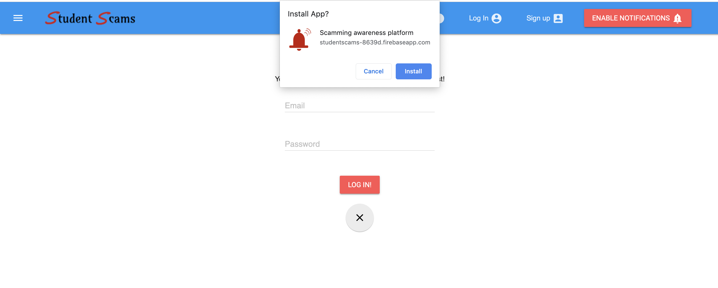

Figure 11 - Desktop app installation prompt

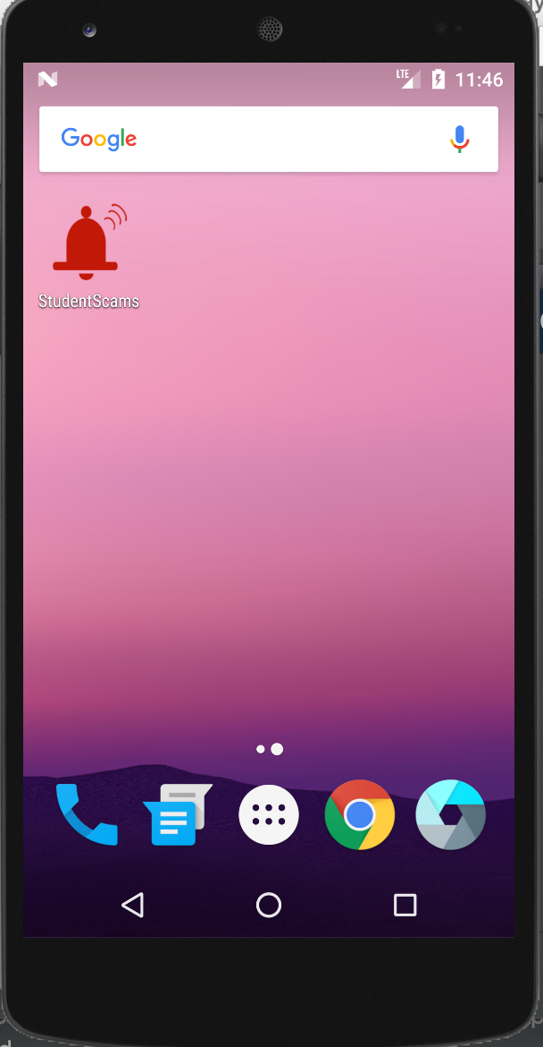 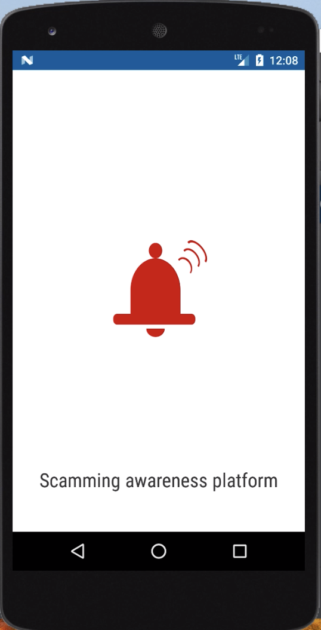

Figure 12 - Installed application on Android mobile device and splash screen displayed on launch

A manifest file was used to allow installation of the application. This file listed different sized icons to cater for all device sizes ranging from 48 pixels to 512 pixels. This file also determined which background colour, theme colour and starting page would be displayed to the user when installed.

## **5.2. Technology choices**

Different decisions had to be made during the project in regard to technology used. Techniques had to be experimented with and evaluated afterwards to determine which would be better suited to the PWA.

### **5.2.1 Caching strategies**

During development of the application a selection of caching strategies were experimented on using the cache API to store content for offline use, as well as to retrieve content when a network request failed. For the static assets of the application such as the files that create the application shell, a ‘Cache only’ strategy was used since these files are added to the cache when the service worker is installed and the files are unlikely to change so fetching the files from the cache provides a quicker response time which can provide a better user experience.

A ‘Cache, then network’ strategy was used for the dynamic content of the application, which would be ‘progressively’ cached as the user navigates around the application (Figure 13). This strategy retrieves content from the cache first whilst a request is simultaneously made to the service worker which will check the network for the same item. The advantage of this approach is that it reduces the response time of displaying content since it’s accessing the cache first to retrieve the content, and this content is updated if the network request finds an updated version of the item (Google 2018). Other strategies were explored such as ‘Network with a cache fall-back’ however this strategy could be ineffective if a network connection is poor, meaning the cache fall-back will not execute until the network has completely failed. This could result in no content appearing in the application for a period of time.

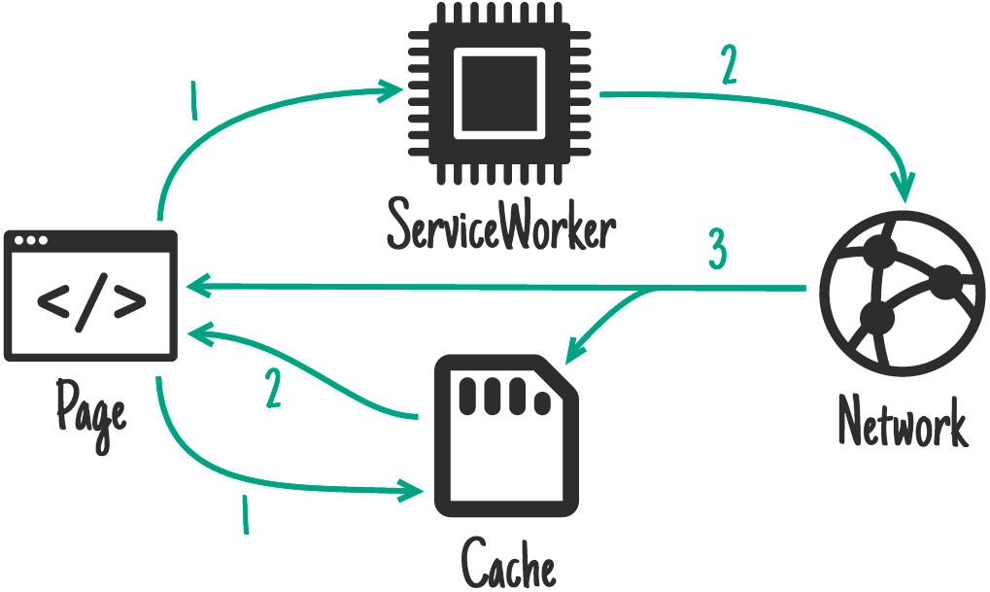

Figure 13 - Cache then network strategy (Google 2019)

### **5.2.2 IndexedDB**

The previous section described how different files and requests were stored in the cache to help offline functionality, however the applications post content which is received in the form of JSON (JavaScript Object Notation) from a REST (Representational state transfer) endpoint was stored in a client-side database called IndexedDB. The applications posts were stored in an object store called ‘posts’ which would be read from the object store if the original network request had failed to retrieve the posts from the backend database (**Figure 14**). This resulted in scamming posts always being presented to the user, even without an internet connection.

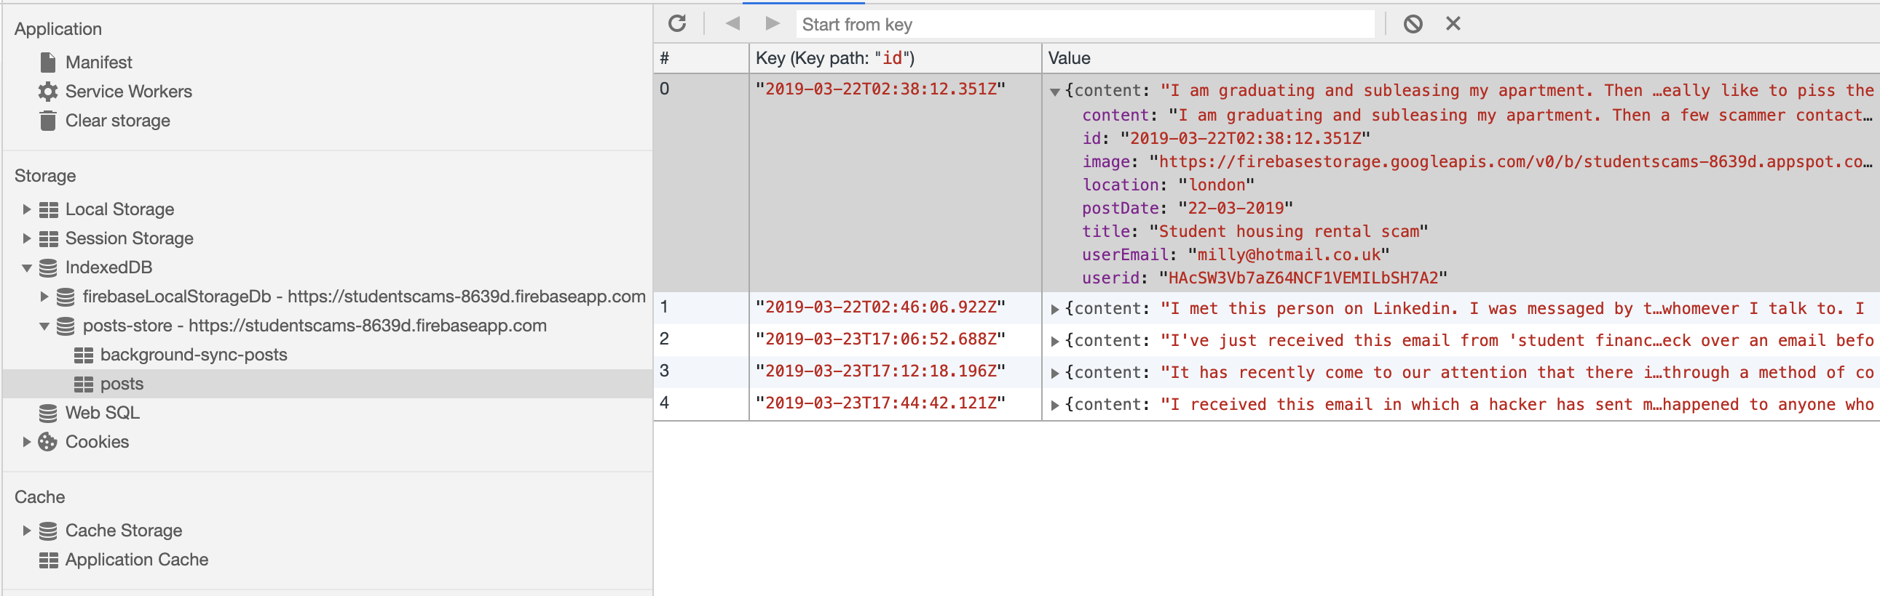

Figure 14 – IndexedDB database storing scamming posts

To assist with development with IndexedDB, a library called ‘IDB’ was used to increase efficiency of development during the process (**see footnote**). IDB makes minor improvements to IndexedDB which allows promises to be used as an alternative (Google 2018). This increased productivity since throughout the course of development promises had been used already, so this reduced the learning curve as opposed to learning IndexedDB individually (MDN Web Docs 2019).

[1]

### **5.2.3 Node package manager**

To assist with development of the previously mentioned technology choices, certain processes were simplified with the help of packages which assisted productivity during development of the application. Node package manager (NPM) was used which aided installation of many different packages used throughout the project from the command line and provided a simple method to start a development server which would compile all the files in the root folder of the project. This server was used to experiment with code and helped implement new features. NPM helped integrate new technologies into the project throughout the duration of the development process, for instance firebase cloud functions were integrated later on in the project using the ‘npm install’ command.

### **5.2.4 Firebase**

Firebase was chosen to help increase the efficiency of the development process. It offers user authentication, data storage and notifications all on the same platform, which made development of the application quicker as no server and data storage had to be developed. Firebase’s database ‘Firestore’ helped store data about users, scamming posts and notifications. Firebase cloud functions assisted with server-side development which would execute backend code attached to the cloud function when a ‘POST’ request was made to the specified function. Firebase cloud functions were chosen over alternative server-side languages such as PHP as they helped maintain a consistent code base from front-end through to backend and they helped promote faster development by keeping all the code in JavaScript. Once features were tested using the development server locally, the files would then be deployed to firebase’s hosting sever using the command ‘firebase deploy’ to view the application through a hosted URL link.

### **5.2.5 Material Design Lite**

The application was built using a front-end framework called Material Design Lite (MDL). MDL was chosen as a framework as opposed to other alternatives because of its attractive templates and bold features which gave the application a modern view. This method improved efficiency during development since styling did not need to be applied to every UI element on the screen due to MDL, which offers pre-designed features which are implemented using simple class names.

## **5.3 Artefact reflection**

The process of developing the produced artefact (PWA) was extremely valuable, with new techniques and knowledge being learned as development progressed. During this process, any problems encountered were dealt with. The features implemented were finished on time, which left a suitable timeframe to conduct usability tests and interviews. Due to the app being progressive, this meant features of it were progressively added and presented to the user (Google 2019). This meant that different fall-backs had to be taken into account when implementing features so that the user experience (UX) was not affected. One example of the fall-backs implemented was an offline feature called background synchronisation, that was used to store posts that had been posted without an internet connection, which in turn would then be posted as soon as the user re-established an internet connection (Figure 15).

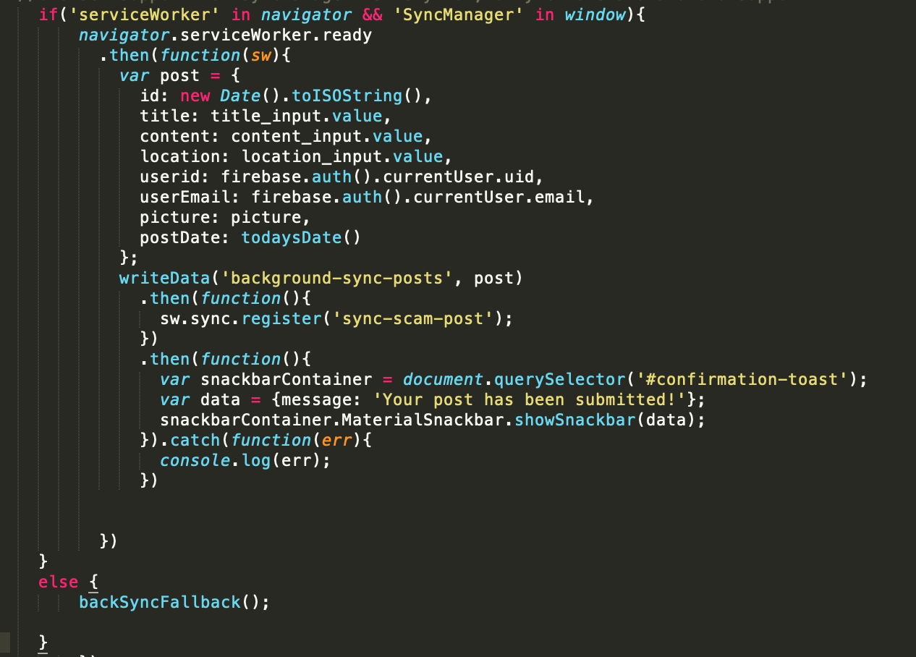

Figure 15 – JS code for background synchronisation of scamming posts

During development, it was noted that support for this feature was very low across browsers (MDN Web Docs 2019), so if a user was to use this on a browser such as Safari iOS, posting a scamming experience or story would not work. To overcome this, a fall-back function was used in case the browser did not support the SyncManager API (Figure 16).

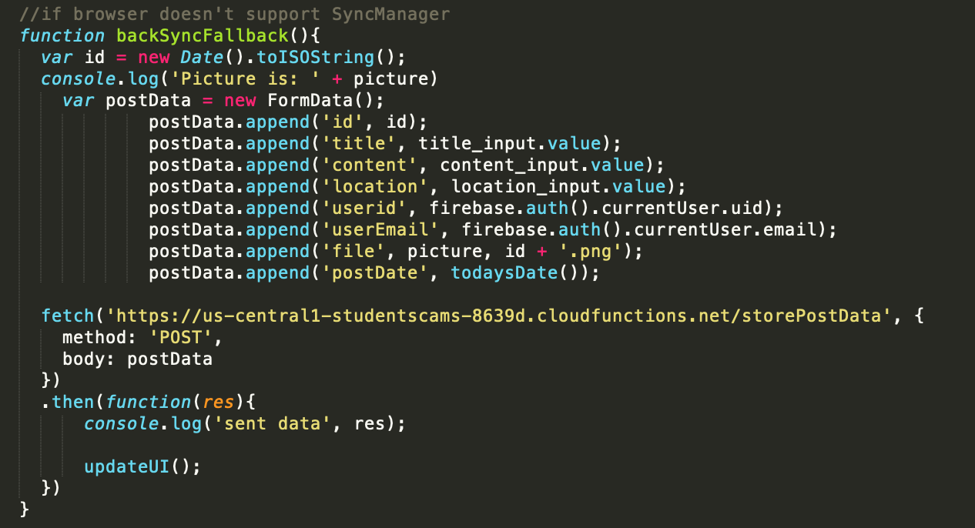

Figure 16 – JS code run when background sychronisation is not supported in the browser

Here it can be seen that if the browser does not support the ‘SyncManager’ API, the ‘backSyncFallback’ function is called which instead sends the post data via the Fetch API in a ‘POST’ request. The result of this meant that users would always be able to submit a scamming post without any errors arising due to browser support.

One problem that occurred during development was that the Firebase database used for the project did not support full text search (Firebase Docs 2019). A search function was a potential feature that was included in the original project plan and was thought to be highly beneficial to the application. Alternatives were looked into such as ‘Algolia’ and ‘ElasticSearch’, however implementing any of these required an upgrade to Firebase’s plan which was not possible. Although a search feature could not be implemented, this was overcome by identifying new features that could benefit users of the application. The camera and image upload function were outlined as features that could help improve the user experience by providing evidence of the talked about scams or uploading a picture to summarise the post, which all add value to what is presented to the users. This demonstrated that when a feature could not be implemented, adding another feature could still benefit the users of the application.

Following on from this feature, a problem was identified that if the user did not upload an image with their scamming post, an error occurred, and the post was not submitted. This was due to the way the server-side code (Firebase cloud functions) was written, which expected an image to be present when parsing the data. It was decided that a default image would be uploaded if no image is taken or uploaded by the user as this would keep the format of each user’s scam post consistent and keeping a consistent layout is important in providing an improved user experience (Black 2015). In order to upload a default image, firstly it was checked if an image was taken or uploaded by the user (Figure 17), if this step was not completed then the chosen default image would have to be converted to a file which would then be uploaded to the server. This was done using a function to convert the URL (Uniform Resource locater) of the default image into a file (Figure 18). The result of this meant that users had to the option to upload an image or picture, however if they did not upload an image or take a picture, an error did not occur as a result of this.

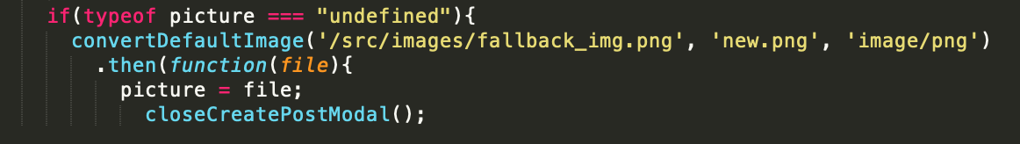

Figure 17 – JS code that executes when no picture has been uploaded by user

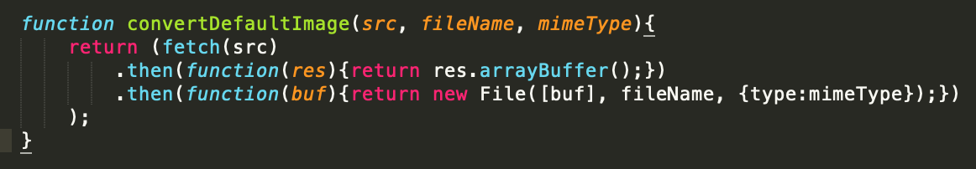

Figure 18 – JS function used to convert image to a file

Another problem that was noticed towards the end of development during the testing phase was that the splash screen would function as expected on an android device, however a blank white screen would display when opening the app on an iOS device. It was found that the reason for this was because android automatically creates a splash screen using the manifest file as long as the requirements are met (see Appendix J**)**, however iOS does not share this. After researching into this, it was found that media queries could be used along with the appropriate link tags to display a splash screen for all iOS device sizes (Figure 19). This was important because a splash screen helps PWAs look and feel more like a native app (Apple Docs 2016).

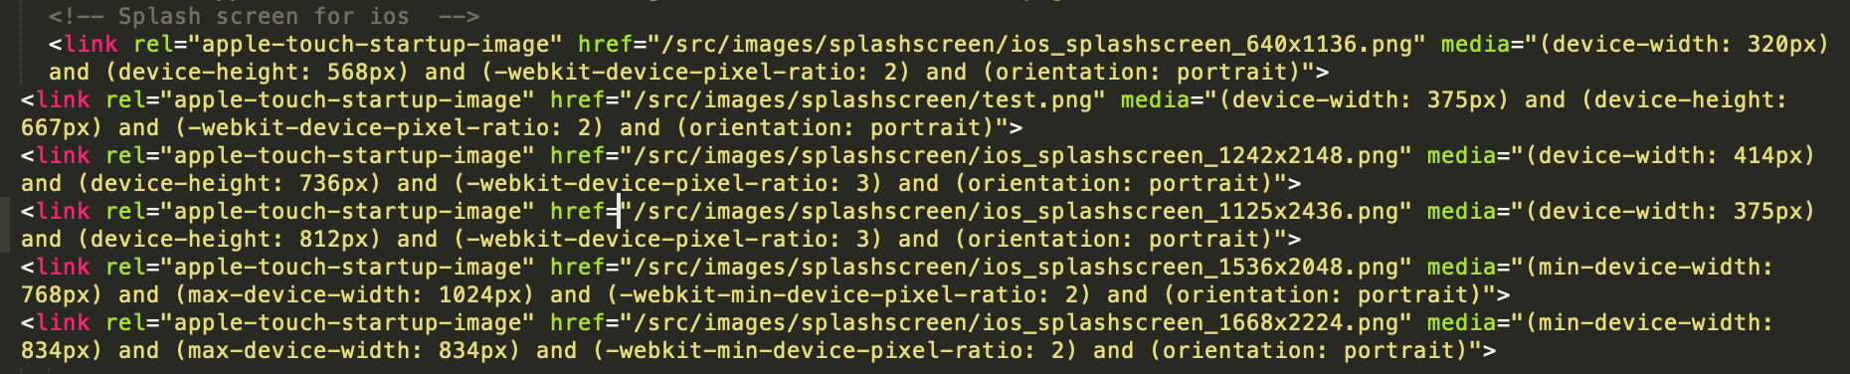

Figure 19 – HTML code that displays a splashscreen image depending on the size of the device

Overall, this process required extensive research skills, and helped enhance and apply technical skills to various features of the application. Problems arose during the process, in which the majority were resolved, or if they could not be resolved an alternative feature was implemented.

# **6. Results**

Turning now to the results section which states the overall findings from the project which are followed by a discussion. Firstly, this section presents the benchmarking result which displays the different metrics achieved from the Lighthouse audit and looks closer into the individual tests used to class an application as a ‘progressive web application’. Secondly, the section moves on to display the qualitative results gathered from the interviews.

## **6.1 Artefact results**

At the beginning of the project, it was decided that the PWA would be evaluated using Lighthouse, in which a PWA metric score of 90 or above was aimed for. However, after a recent update to the Lighthouse tool, the ‘progressive web app’ metric had been changed (Figure 20**),** which resulted in the PWA not being evaluated out of a score of 100. As a result of this, the PWA was alternatively evaluated by checking which PWA tests it did pass. From Figure 21, it can be seen that the produced PWA passed all the required checks to be classed as a progressive web application.

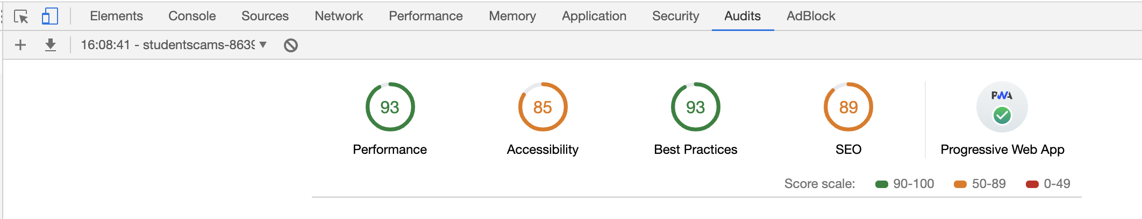

Figure 20 – Lighthouse audit results

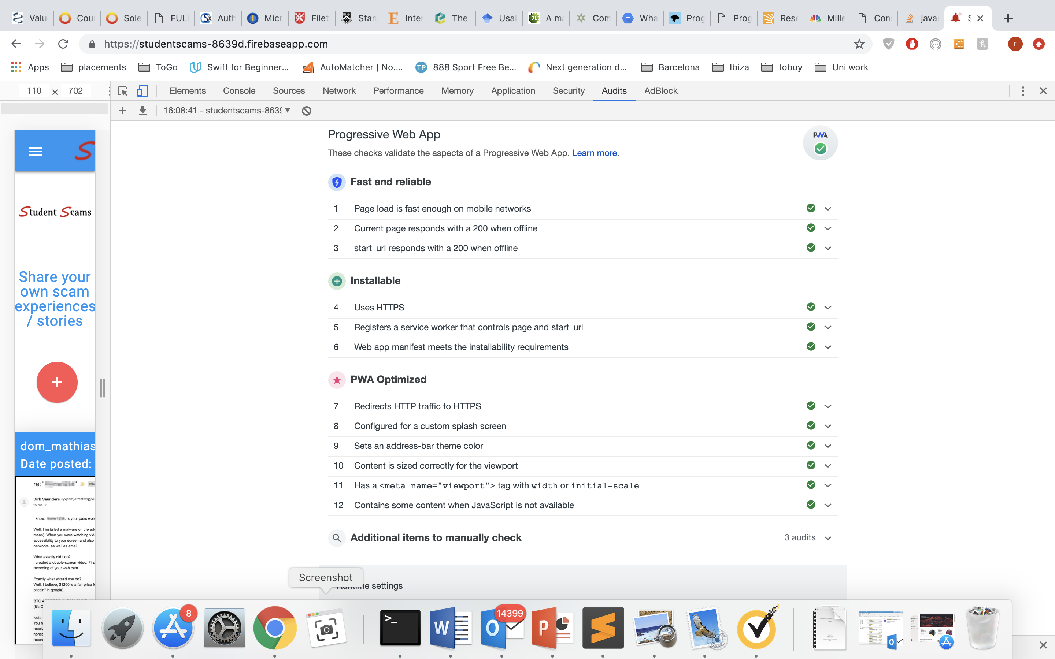

Figure 21 – Progressive web app tests

After browser testing, the finished PWA resulted in a cross-browser compatible site which keeps a consistent CSS design throughout (see Appendix K). Device testing was also conducted to confirm the site was cross-device compatible working on desktop, mobile and tablet (see Appendix L).

## 6.2 Interview results

Five overall themes were identified, with one theme having 2 sub-themes. The five main themes were “social media”, “finding specific scams easier”, “warning new students”, “features help increase scam knowledge” and “lack of awareness” (Figure 22). The produced themes are quite general as the codes behind the themes were quite descriptive, so general phrases were used to group these descriptive codes into more readable themes.

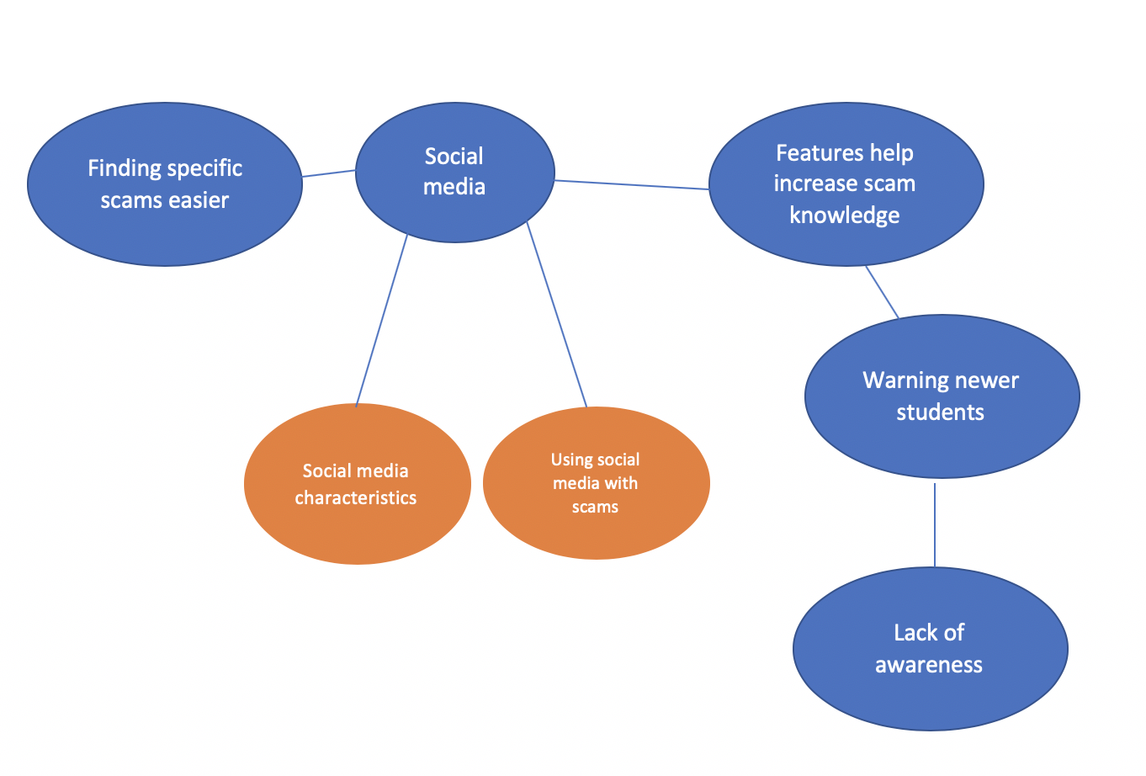

Figure 22 – Thematic map displaying Main themes (blue) and sub-themes (orange)

### **6.2.1 Social media**

Social media was mentioned by participants in different contexts, which led to splitting the main theme into two further sub-themes called “using social media with scams” and “social media characteristics”.

#### **6.2.1.1 Using social media with scams**

Participants described social media as a tool that they had used which had updated their knowledge of scams and that they would use it as a method when they had raised suspicions of a potential scam in the past. The social media platforms that participants specifically mentioned were Facebook, Twitter and YouTube. An example mentions using Twitter as a method for when they are unsure of a potential scam:

*“I would type in the problem to social media like Twitter using the hashtag to see if anyone has had that problem”*

(Participant 1)

Participants also described learning about different scams through other users posting about them on Facebook. One participant recalled YouTube helping identify a specific type of scam to them when they were asked if they knew about any of the scams presented to them:

*“I actually knew about this one by being subscribed to people on YouTube who get their own back at scammers and this seems to be a pretty common one, they receive emails like this, and basically ring them back and basically hack them back.”*

(Participant 3)

#### **6.2.1.2 Social media characteristics**

The produced PWA was described by participants to have social media characteristics. They went on to describe features of the application to ones they had previously used. One participant described the hamburger navigation of the application to feel and look like Twitter:

*“The dropdown menu makes it look and feel like twitter how it's in the top left, which gives you the options with your account... it's a similar thing. It kind of moulds the website and app feel together quite well.”*

(Participant 5)

The application was also described to have a similar feeling to social media when reading through the different stories posted by other users due to how comforting it was to read other people’s experiences:

*“It's not social media, but it's got that tint to it as it's quite comforting to read other people’s stories...”*

(Participant 5)

Participants also went on to state ways in which the application could be improved, whilst referencing to social media such as Facebook commenting.

*“So I think you've got the email address of the person who posted it, so you can get in contact with the person who posted it if you want, but a small comment section beneath, like Facebook commenting, to get quick feedback and I’m sure that would go well with notifications”*

(Participant 3)

### **6.2.2 Findings scams easier**

Participants stated different features that could improve the application further, in which participants recommendations overall wanted to make finding scams easier. A common feature that participants stated that would be beneficial was a search feature to help navigate directly to specific types of scams instead of reading through every scam posted.

*“the only thing I would say is... not so much a negative but something that could be improved on is that it could have a search feature so that if you were looking for a specific scam that's happened to you or anyone else they could search and then if something with a similar title comes up they can go straight to that post rather than having to scroll through having to find it.”*(Participant 2)

Categorisation of the scamming posts was also another feature that was deemed beneficial by participants in navigating to different posts. One participant stated that they would like a categories option when asked what further features they would like to see:

*“A categories option, so a view by categories, so view by email phishing, view by student housing rental... just so you can filter out ones that really aren't relevant to what you're looking for. Say if I was approached by an email hacker, I’d only want to see email ones.”*

(Participant 3)

### **6.2.3 Warning new students**

The participants mentioned how they would use the presented application to warn new university students of the different scams. One participant mentioned how the application would be effective at highlighting landlord related scams and issues to university students who are new.

*“I think student housing is a massive problem, I genuinely think, I know that they have a few laws trying to sort it out at the moment, but nothing can really prepare you for how badly you can be screwed over by landlords or estate agents when you’re a student, and I think this would be a really good way of highlighting that to new students and I would be happy to use it to... because I’ve had so many bad experiences of overpaying rent, my landlords walking in my house when they feel like it and it would be really nice to be able to tell... obviously students will be moving into this house in a few months’ time, it would be nice to tell new students quite openly, because otherwise they don’t get what they deserve(landlords) and could potentially get scammed.”*

(Participant 1)

It was also suggested that the application could be used to warn new foreign students, who may not have the best scamming knowledge and may have communication barriers, which could make them more vulnerable.

*“Maybe towards the lead-up to a freshers time, where there's lots of foreign students coming over to England who don’t have as much knowledge, they may not speak any English at all, so maybe having something like this available to them to say like coming here, you're in a new country there might be people who want to take advantage of you... so look out for these things... and then the university could employ this app in that kind of way to help university students out... or anyone really. Freshers who have missed out on halls or something, say if their parents don’t take charge and they're desperate for accommodation, they may believe anything.”*

(Participant 5)

### **6.2.4 Features help increase scam knowledge**

The applications current features were described by participants as helping increase their knowledge of scamming as well as other peoples. The notifications feature was highlighted as a feature that could help build up a student’s scam knowledge which would give them the ability to detect scams in the future. A participant mentioned how the notifications feature in particular was beneficial in providing knowledge of a scam that may be used in the future:

*“So obviously you've got a notifications part so that when a new post is added it pops up on your laptop which I feel is beneficial as you don't know how regular things are happening, but it would take you 2 minutes to have a quick read through and see if you can relate, or it would give you the knowledge in the future that this is what happens if you do get something like that you can just flag it and put it in your spam. So yeah the enable notifications button is quite useful.”*

(Participant 2)

Several participants praised the picture upload function of the application, stating that it was useful in providing evidence of the posted scam to other users. A benefit stated about the feature was that it could provide knowledge of the emails used by scammers which could then be remembered for the future.

*“yeah so like this name here *points at image on hacker email scam post*, or the email that sent this shown in the picture is good to see the names of the scammers which you could keep in mind for the future.”*

(Participant 3)

Ordering the scam posts of the application in date order from most recent to oldest was considered an important factor of how the posts were presented. This order was said to help give an idea to users of how frequent a scam is being used and talked about.

*“everything is in date order so it's quite easy to see what the most recent ones are so you can get an idea of which ones are retired / older scams that aren’t used anymore.”*

**(Participant 4)**

### **6.2.5 Lack of awareness**

Participants showed a lack of awareness during the interviews towards some of the scams presented in the application. Every participant stated that they were not previously aware of LinkedIn scams or Chinese international student scams.

*“I have only heard of half of these ones that you have on the app, I had no idea you can get scammed through LinkedIn, I wouldn't have guessed they did so that does raise awareness to different methods.”*(Participant 3)

However, all participants demonstrated awareness towards a particular email scam in which a ‘hacker’ claims to have control of a person’s email account. Awareness of this stemmed from hearing similar stories from friends, receiving similar emails themselves and through social media platforms.

*“I've definitely heard of this... the email one claiming to have the control. I actually knew about this one by being subscribed to people on YouTube who get their own back at scammers and this seems to be a pretty common one, they receive emails like this, and basically ring them back and basically hack them back.”* (Participant 3)

## 6.3 Discussion

The aim of this study was to research into what ways the produced PWA could help raise awareness to university students on the latest scamming tactics. The findings demonstrated that the participants would engage with the application which may suggest the potential for a PWA to increase a student’s awareness on scamming. Results also suggested that the application had similarities to social media platforms and navigating to specific scams quicker could improve the application’s effectiveness at raising awareness.

Social media was commonly used by participants as a method to find more information on a potential scam, in which they also outlined similarities that the PWA shared with social media. According to Yin et al. (2015), social media has been found to be an effective tool in raising awareness to emergency situations. This raises an important indication that if the developed PWA shares social media characteristics, this may increase its effectiveness at raising awareness on scamming. Furthermore, social media was a popular method used by participants to detect scams, so participants stating similarities about it further suggests the suitability of the platform as a whole for scam related information as it’s being described by students as a method they already use to find more information on scams. The students recommended ways in which the application could be improved which referenced social media such as Facebook commenting. Hutter et al. (2013) found that user engagement on Facebook can lead to positive effects on brand awareness. This creates the view that if the developed PWA was directed more towards social media by incorporating more characteristics such as commenting, this could increase its effectiveness in raising student’s awareness.

Participants proposed that the PWA can lead to social interaction outside of the application by using other student’s emails which could lead to important discussions and this could help clarify any gaps in knowledge one may have. Furthermore, social interaction created from this app can amplify the reach of the content if people are having discussions about various scamming topics outside of the application, this can lead to the knowledge being spread between each user’s social network.

A theme that links with the ‘social media’ theme called ‘finding scams easier’ represents how simplifying the process of navigating to a particular type of scam is regarded as an important factor when trying to improve one’s knowledge on scamming. This theme shows that a search feature and categorisation of scamming posts are seen as the most beneficial features to improve this application’s effectiveness of increasing university student’s awareness on scamming. Interestingly, this theme links directly with the ‘social media’ theme because participants described how they would use the search feature on social media to find more information on scams, whilst also suggesting it as a feature to improve the application. This finding further supports the view that aiming the application more towards social media could improve its effectiveness on raising awareness on scams to university students.

Students found the tool engaging and perceived the tool would be beneficial in helping new university students. Benefits were identified for current university students as well, however the vulnerabilities of new university students and international students were key highlights. International students could be seen as a more vulnerable group due to possible language barriers and some may have a significant lack of knowledge to their environment compared to what they are used to from their home country which can often result in them being more vulnerable to scams (Nkotagu 2011). This indicates that this application could prove a beneficial platform for these students to read through each of the posts to increase their knowledge of scams, as well as subscribing to push notifications to keep building their knowledge of scams.

Different features of the application were described as being beneficial in increasing student’s knowledge of scamming. The results show that the notification feature would be beneficial in keeping student’s knowledge of scams up to date as it prompts the user every time a new post is added, which attempts to re-engage the user with the application and read through the post(s) they have not seen. Displaying evidence of particular scams by uploading a picture was an important factor in raising participants awareness as it not only displayed evidence of the scam which had been written about, but it also displayed the exact contact details of scammers as well which would make students more aware for the future. Furthermore, attaching photographic evidence with a scamming post increases its authenticity which could increase the likelihood students will remember it in the future. In addition to this, ordering the posts in date order was essential as it indicated whether a scam was recently posted about or if it’s an older scam. This implies that displaying the post date for each scam can help increase student’s awareness about how recently a scam has been attempted.

From the study, students demonstrated a lack of awareness to a selection of the scams presented in the application. In particular, all students had zero prior knowledge to LinkedIn scams and Chinese international student scams. This insinuates that after using the application and reading through the 5 scamming posts displayed, the application demonstrates potential in increasing students’ knowledge of scams. Building on from this, if this application displayed a larger collection of scams and the application was used by a larger sample of university students, this could suggest that the application would be extremely beneficial in increasing students’ awareness to different types of scams.

However, this study has several limitations. Due to the scope of an undergraduate project, only 5 interviews could be conducted. This resulted in a small sample size being used which was created in an English context, therefore this study does not consider cultural diversity which is often very important in qualitative research (Allmark 2004). It is suggested that future studies include participants from multiple countries to improve upon this. The study asked participants to follow the same instructions set by the researcher during the usability tests which could potentially include some form of researcher bias since this influences what the participants see. However, this does provide a straightforward framework which is easy to replicate for future studies. It is also acknowledged that the application was not tested in a naturalistic setting which could influence participants responses compared to participants using the application in their natural setting. Using purposive sampling is a potential limitation of the study as it can be highly prone to researcher bias. Purposive sampling however did ensure that participants selected for the study were suitable in order to help answer the research question.

# **7. Conclusion**

The purpose of this study was to understand the different ways a PWA could help raise awareness to university students on scamming. The study entered an untouched field of research on how a PWA can be used to increase one’s awareness on scamming. After several usability tests and interviews with university students, 5 main themes were identified. These themes were: “Social media”, “Findings scams easier”, “Warning new students”, “Features help increase scam knowledge” and “Lack of awareness”.

Results from the research study illustrated that new university students may benefit more from the application compared to existing university students. Although, notifications and image upload features were deemed effective at increasing any university student’s scamming knowledge for the future. To improve the applications effectiveness in raising awareness to university students on scamming, the application should be aimed to focus more around social media. Implementing a search feature, categorisation of the scamming posts and commenting would work towards this aim. The application was well received by all students, and it demonstrated potential effectiveness in increasing students’ awareness to at least two types of scams.

Overall, the development process of the prototype PWA was a success. All of the required prototype features stated in the project specification were implemented to an appropriate standard. Although the ‘ideal’ search feature could not be implemented, alternative features (Camera and image file upload) were implemented to provide different benefits to the user which were equally as important. The technology choices made throughout the project were effective in ensuring that users of the application were provided content despite not having an internet connection. The PWA offered cross-browser compatibility and cross-device compatibility, therefore increasing the accessibility of the application for university students. Audit results taken from Lighthouse demonstrated that the application passed all PWA tests set by Google therefore showing that participants were presented with a certified PWA during the research study.

On reflection, the development process of the project was efficient in terms of the time taken to implement the features, however the readability of the code written could be improved, in particular the code written to change different UI (User interface) elements. A framework could be beneficial in improving this by reducing the number of lines of code written, so it is recommended for future studies to include a JavaScript framework such as React or Angular to assist in maintaining readable code and to make development of UI elements more efficient.

# **8. References**

ALLMARK, P., 2004. Should research samples reflect the diversity of the population?. Journal of Medical Ethics, 30(2), pp 185-189

APPLE DOCS., 2016. Configuring Web Applications [viewed 28 April 2019]. Available from: <https://developer.apple.com/library/archive/documentation/AppleApplications/Reference/SafariWebContent/ConfiguringWebApplications/ConfiguringWebApplications.html>

ATAR, T., 2017, Building Progressive Web Apps: Bringing the Power of Native to the Browser. United States of America: O’Reilly Media

BAILY, J., MITCHEL, R., and JENSEN, B, 2008. Analysis of Student Vulnerabilities to Phishing, AMCIS 2008 Proceedings. 271

BLACK, S. 2015. Current Practices for Product Usability Testing in Web and Mobile Applications. [viewed 28 April 2019]. Available from: <https://scholars.unh.edu/cgi/viewcontent.cgi?article=1228&context=honors>

BRAUN, V and V, CLARKE. 2006. Using Thematic Analysis in Psychology. Qualitative research in psychology. 3(2) pp 77-101

BRAUN, V et al. 2019. Thematic Analysis. Handbook of Research Methods in Health Social Sciences, Springer, pp 843 – 860

CHAFFEY, D., 2018. Mobile marketing statistics compilation [viewed 25th April 2019] Available at: <https://www.smartinsights.com/mobile-marketing/mobile-marketing-analytics/mobile-marketing-statistics/>

CRESWELL, J.W. 1998. Qualitative inquiry and research design: Choosing among five traditions. Thousand Oaks, CA: Sage Publications

CRESWELL, J.W., and CRESWELL, J.D., 2018. Research design: qualitative, quantitative & mixed methods approach. 5th ed. Los Angeles: SAGE

DHAMIJA, R., TYGAR, J.D and HEARST, M., 2006. Why Phishing Works. In: CHI-2006. Conference on Human Factors in Computing Systems. Canada. CHI-2006, pp 581-590

DICICCO-BLOOM, B and CRABTREE, B,. 2006. The qualitative research interview. Medical education, Vol.40(4)

DOWNEY, L. 2007. Group Usability Testing: Evolution in

Usability Techniques, Journal of usability studies, 2(3), pp 133 – 144

FEDERAL TRADE COMMISSION, 2018. Consumer Sentinel Network. United States: Federal Trade Commission

FIREBASE DOCS., 2019. Full-text search | Firebase [viewed 28 April 2019]. Available from: <https://firebase.google.com/docs/firestore/solutions/search>

FRANSSON, R, and DRIAGUINE A. 2017. Comparing Progressive Web Applications with Native Android Applications . Diva Portal[viewed 13 February 2019] Available from:

<http://www.diva-portal.org/smash/get/diva2:1105475/FULLTEXT01.pdf>

GARRETT, J., 2010. The Elements of User Experience: User-Centered Design for the Web and Beyond. 2nd ed. Johanneshov: TPB

GAVETT, E et al. 2017, Phishing suspiciousness in older and younger adults: The role of executive functioning. PLOS ONE 12(2)

GOOGLE DEVELOPERS,. 2019. Progressive Web Apps | Progressive Web App Checklist | Google Developers [viewed 28 April 2019] Available from:

<https://developers.google.com/web/progressive-web-apps/checklist>

GOOGLE DEVELOPERS,. 2018. Progressive Web Apps Training | Caching Files with Service Worker | Google Developers [viewed 28 April 2019] Available from:

<https://developers.google.com/web/ilt/pwa/caching-files-with-service-worker>

GOOGLE DEVELOPERS,. 2018. Progressive Web Apps Training | Working with IndexedDB | Google Developers [viewed 28 April 2019] Available from:

<https://developers.google.com/web/ilt/pwa/working-with-indexeddb>

GOOGLE DEVELOPERS,. 2018. Tools For Web Developers | Lighthouse | Google Developers [viewed 28 April 2019] Available from:

<https://developers.google.com/web/tools/lighthouse/>

GOOGLE DEVELOPERS,. 2019. Tools for developers | Configured For A Custom Splash Screen| Google Developers [viewed 28 April 2019] Available from:

<https://developers.google.com/web/tools/lighthouse/audits/custom-splash-screen>

GOOGLE DEVELOPERS,. 2019. Web Fundamentals | The Offline Cookbook | Google Developers [viewed 28 April 2019] Available from:

<https://developers.google.com/web/fundamentals/instant-and-offline/offline-cookbook/#cache-then-network>

GOOGLE DEVELOPERS,. 2019. Web Fundamentals | Your First Progressive Web App | Google Developers [viewed 28 April 2019] Available from:

<https://developers.google.com/web/fundamentals/codelabs/your-first-pwapp/>

GOOGLE DEVELOPERS,. 2019. Web Fundamentals | Offline Storage for Progressive Web Apps | Google Developers [viewed 28 April 2019] Available from:

<https://developers.google.com/web/fundamentals/instant-and-offline/web-storage/offline-for-pwa>

HUME, D. 2017, Progressive Web Apps. United States of America: Manning

HUTTER, K,. et al. 2013. The impact of user interactions in social media on brand awareness and purchase intention: the case of MINI on Facebook. Journal of Product & Brand Management, 22(5/6), pp 342 - 351

JOHANNSEN, F., 2019. Progressive Web Applications and Code Complexity : An analysis of the added complexity of making a web application progressive [viewed 28 April 2019]. Available from: <http://www.diva-portal.org/smash/record.jsf?pid=diva2%3A1230204&dswid=1840>

JONES, H. et al. 2019. Email fraud: The search for psychological predictors of susceptibility, Plos One, Vol.14(1)

KIM, M., 2014. THE EFFECTS OF EXTERNAL CUES ON MEDIA HABIT AND USE: PUSH NOTIFICATION ALERTS AND MOBILE APPLICATION USAGE HABITS [viewed 15 April 2019] Available from: <https://d.lib.msu.edu/etd/3263/datastream/OBJ/download/The_effects_of_external_cues_on_media_habit_and_use___push_notification_alerts_and_mobile_application_usage_habits.pdf>

KIRWAN, G., C, FULLWOOD and B, ROONEY, 2018. Risk Factors for Social Networking Site Scam Victimization Among Malaysian Students. Cyberpsychology, Behavior, and Social Networking, 21(2)

KLEITMAN, S., LAW, M.K.H. and, K.JUDY., 2018. It’s the deceiver and the receiver: Individual differences in phishing susceptibility and false positives with item profiling. PLoS One, 13(10)

RIESSMAN, C., 1993. Narrative analysis. Newbury Park, Calif.: Sage

KRUMM, J., N, DAVIES and C, NARAYANASWAMI. 2008. User-Generated Content. IEEE Pervasive Computing, 7(4), pp 10-11

KUTCHER,E and J, BRAGGER., 2004. Selection Interviews of Overweight Job Applicants: Can Structure Reduce the Bias?, Journal of Applied Social Psychology, 34(10)

LONSDALE, J. et al. 2016. National trading standards – Scams team review. Cambridge: RAND[viewed 13 February 2019] Available from:

<https://www.rand.org/content/dam/rand/pubs/research_reports/RR1500/RR1510/RAND_RR1510.pdf>

MAJCHRZAK, T,. BIORN-HANSEN, A,. and GRONLI, T,. 2018. Progressive Web Apps: the Definite Approach to Cross-Platform Development?. In: Semantics Scholar, Hawaii International Conference on System Sciences, 51st, Norway, pp 5735 – 5744

MAJCHRZAK, T,. BIORN-HANSEN, A,. and GRONLI, T,. 2017. Progressive Web Apps: The Possible Web-native Unifier for Mobile Development, Conference: 13th International Conference on Web Information Systems and Technologies

MALAVOLTA, I. 2016. Beyond native apps: web technologies to the rescue!. In: Proceedings of the 1st International Workshop on Mobile Development. ACM, pp 1-2

MALAVOLTA, I. et al, 2017. Assessing the impact of service workers on the energy efficiency of progressive web apps. In: MOBILESoft ’17. Proceedings of the 4th International Conference on Mobile Software Engineering and Systems. Argentina: MOBILESoft ’17, pp 35-45

MDN WEB DOCS, 2019, SyncManager [viewed 28 April 2019] Available from:

<https://developer.mozilla.org/en-US/docs/Web/API/SyncManager>

MDN WEB DOCS, 2019, IndexedDB API [viewed 28 April 2019] Available from:

<https://developer.mozilla.org/en-US/docs/Web/API/IndexedDB_API>

MEHRA, B,. 2002, Bias in Qualitative Research: Voices from an

Online Classroom, The Qualitative report, 7(1), pp 1- 19

METZGER, M., A, FLANAGIN and L, ZWARUN. 2003. College student Web use, perceptions of information credibility, and verification behaviour. Computers & Education, 41(3)

MHASKE, A et al. 2018. Progressive web app for educational system. International Research Journal of Engineering and Technology. Vol.5, Issue.1., pp 310 – 312

MODIC, D. 2012. Willing to be scammed: How self control impacts scam compliance. Exeter[viewed 05 February 2019] Available from: <https://ore.exeter.ac.uk/repository/bitstream/handle/10871/8044/ModicD.pdf?sequence=2&isAllowed=y>

NKOTAGU, G. 2011. Internet fraud: Information for Teachers and students, Journal of international students Vol 1, No.2

PALYS, T,. 2008. Purposive sampling. In L. M. Given (Ed.) The Sage Encyclopedia of Qualitative Research Methods. (Vol.2). Sage: Los Angeles, pp. 697-8.

POURYOUSEFI ,S. and J, FROOMAN., 2019. The Consumer Scam: An Agency-Theoretic Approach, Journal of Business Ethics, 154(1), pp 1–12

QI, B and L. MACKIE., 2014. Utilising Social Media Technology to Raise Brand

Awareness in Higher Education., Bolton, WEBIST 10th International Conference on Web Information Systems and Technologies pp 400 – 405

SAMDAHL, D. 2013. Phishing for Publications: A Word to the Wise. Parks & Recreation magazine, 31 December

SCHEIBE, S. et al., 2014. Forewarning reduces fraud susceptibility in vulnerable consumers, Basic and applied social psychology, 36(3), pp. 272-9

STEINER, T. 2018. What is in a Web View? An Analysis of Progressive Web App

Features When the Means of Web Access is not a Web Browser. International World Wide Web Conference Committee. France, Creative Commons

SUTHERLAND, F. 2014. Scammed and Dangerous: The impact of fraudsters. Scotland: Citizens advice Scotland [viewed 28th April 2019]. Available from: <https://www.cas.org.uk/system/files/publications/Scammed%20and%20Dangerous%20Published.pdf>

UZUNBOYLU, H., N. CAVUS and E. ERCAG, 2009. Using mobile learning to increase environmental awareness. Computers & Education, 52(2)

YIN, J. 2015. Using Social Media to Enhance Emergency Situation Awareness: Extended Abstract. International Joint Conference on Artificial Intelligence. North America

# **9. Bibliography**

ARCHIBALD, J., 2018. Is service worker ready? [viewed 15 April 2019]. Available from: <https://jakearchibald.github.io/isserviceworkerready/index.html>

BASQUES, K., 2018. Debug Progressive Web Apps | Tools for Web Developers | Google Developers [viewed 14 April 2019]. Available from: <https://developers.google.com/web/tools/chrome-devtools/progressive-web-apps#add-to-homescreen>

CRESWELL, J.W. 2009. Research design: qualitative, quantitative & mixed methods approach. 3rd ed. Los Angeles: SAGE

CRESWELL, J.W. 2014. Research design: qualitative, quantitative & mixed methods approach. 4th ed. Los Angeles: SAGE

KOVEN, J. et al, 2019. Lessons Learned Developing a Visual Analytics Solution for Investigative Analysis of Scamming Activities. IEEE Transactions on Visualization and Computer Graphics, 25(1), pp 225 - 234

LARSON, R and LARSON, L,. 2009. Top five causes of scope creep ... and what to do about them. Paper presented at PMI® Global Congress 2009—North America, Orlando, FL. Newtown Square, PA: Project Management Institute

MDN WEB DOCS, 2019. Making PWAs work offline with Service workers [viewed 09 April 2019]. Available from: <https://developer.mozilla.org/en-US/docs/Web/Progressive_web_apps/Offline_Service_workers>

MDN WEB DOCS, 2019, Using the application cache[viewed 3 April 2019] Available from: <https://developer.mozilla.org/en-US/docs/Web/HTML/Using_the_application_cache>

MDN WEB DOCS, 2019. Web App Manifest [viewed 07 April 2019]. Available from: <https://developer.mozilla.org/en-US/docs/Web/Manifest>

MDN WEB DOCS, 2019. Service Worker API [viewed 07 April 2019]. Available from: <https://developer.mozilla.org/en-US/docs/Web/API/Service_Worker_API>

MICROSOFT EDGE DOCS, 2018. Get started with Progressive Web Apps [viewed February 25 2019]. Available from:

<https://docs.microsoft.com/en-us/microsoft-edge/progressive-web-apps/get-started>

NIELSEN, J., 2000. Why You Only Need to Test with 5 Users [viewed 7 March 2019]. Available from: <https://www.nngroup.com/articles/why-you-only-need-to-test-with-5-users/>

SHARMA, E,. 2018. An Introduction to Service Workers in JavaScript [viewed 18 February 2019] Available from: <https://codeburst.io/an-introduction-to-service-workers-in-javascript-27d6376460c2>

SOFO, F et al., 2010. Investigating the relationship between consumers’ style of thinking and online victimization in scamming. International Journal of Digital Content Technology and its Applications. 4(7), pp 38 – 49

TAYLOR, R., 2014. A Pocket Guide to Version Control with Git, Cardiff, United Kingdom: Five Simple Steps

WAHLSTROM, M., 2017. Exploring progressive web applications for health care: Developing a PWA to gather patients’ self assessments. [viewed 8 April 2019]. Available from: <http://umu.diva-portal.org/smash/get/diva2:1143994/FULLTEXT01.pdf>

WOHLFARTH, M., SCHNURR, D and KRAMER,. 2018. Winners, Losers, and Facebook: The Role of Social Logins in the Online Advertising Ecosystem [viewed 26 February 2019] Available from: <https://www.researchgate.net/publication/322522426_Winners_Losers_and_Facebook_The_Role_of_Social_Logins_in_the_Online_Advertising_Ecosystem/citations>

# **10. Appendices**

## **Appendix A – Instructions given to participants during usability tests**

|  |
| --- |
| 1. Read the ‘About’ page |
| 2. Create an account |
| 3. Read through the different scamming posts (5 in total) |
| 4. Subscribe to the apps push notification function |
| 5. Create a post (made up or factual) |

## 

## **Appendix B – Order of questions participants were asked during interviews**

|  |  |
| --- | --- |
| 1. | Have you been involved in any scams during your lifetime? If yes, can you describe what happened? |
| 2. | How easy or hard did you find the app to use? |
| 3. | Did you know about any of the scams posted by other users on the app? If so which ones? |
| 4. | What do you think of the layout of the app? |
| 5. | What positives can you list about the app? (if any) |
| 6. | What negatives can you list about the app? (if any) |
| 7. | What benefits do you feel this app would have for university students if any? |
| 8. | Are there any apps you have used similar to this one? |
| 9. | If you were unsure / suspicious of a possible scam, what would you usually do? |
| 10. | Describe a time where you would use this app |
| 11. | If you were unsure / suspicious of a possible scam, how would you use this platform to seek more information? |
| 12. | What features of this app could you see being beneficial for university students when it comes to scamming? |
| 13. | What further features would you like to see for a platform like this? |
| 14. | Do you want to add any additional info? |

## 

## **Appendix C – 1st draft of codes and themes**

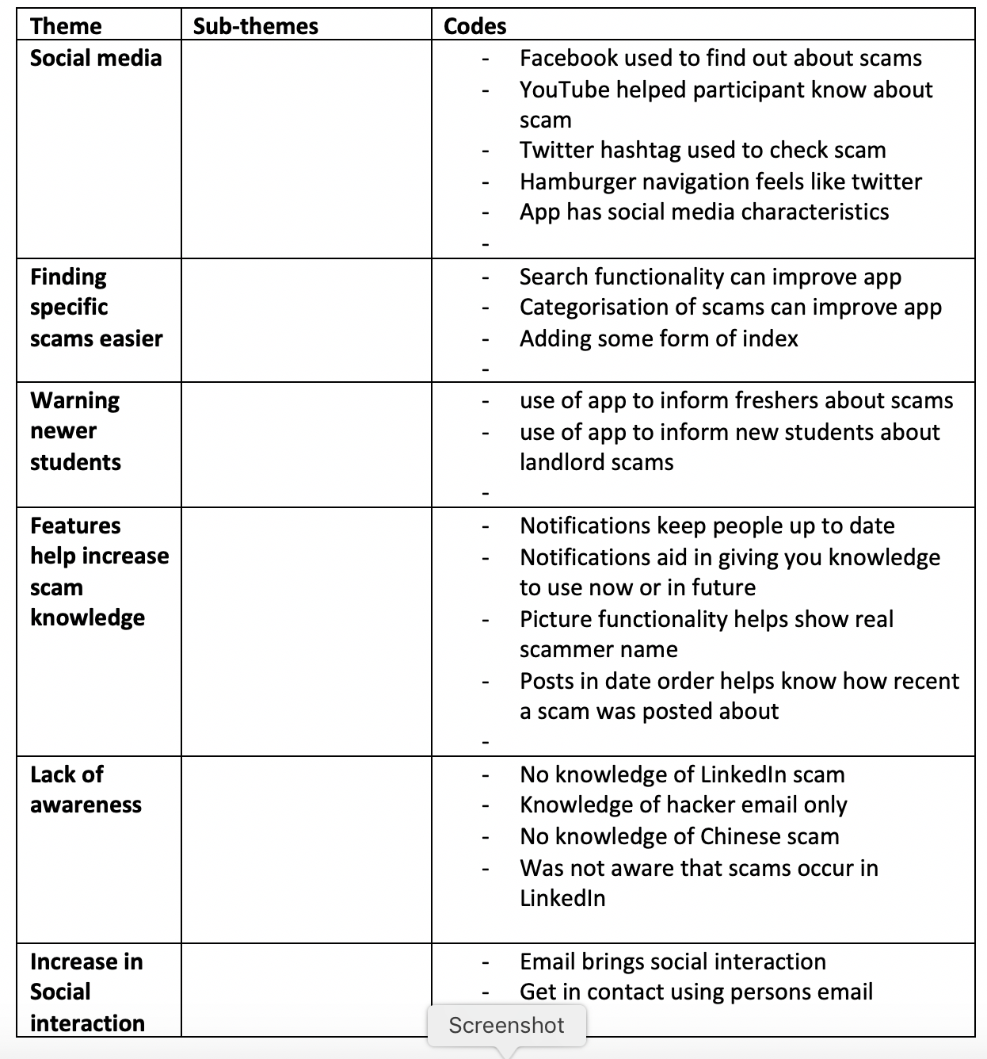

Figure 23 – 1st draft of codes and themes during thematic analysis

## 

## **Appendix D – Re-draft of codes and themes**

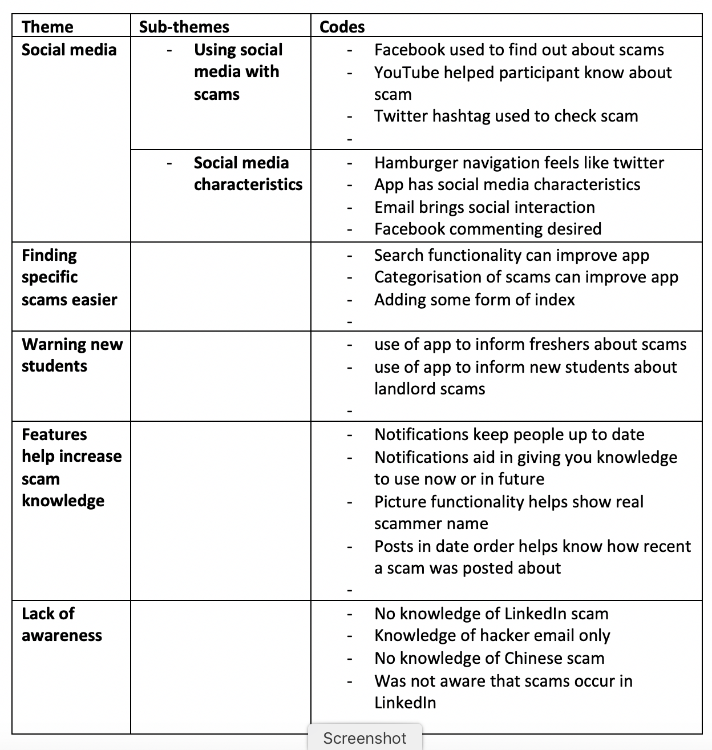

Figure 24 – Final re-draft of codes and themes during thematic analysis

## 

## **Appendix E – Ethical clearance application approval**

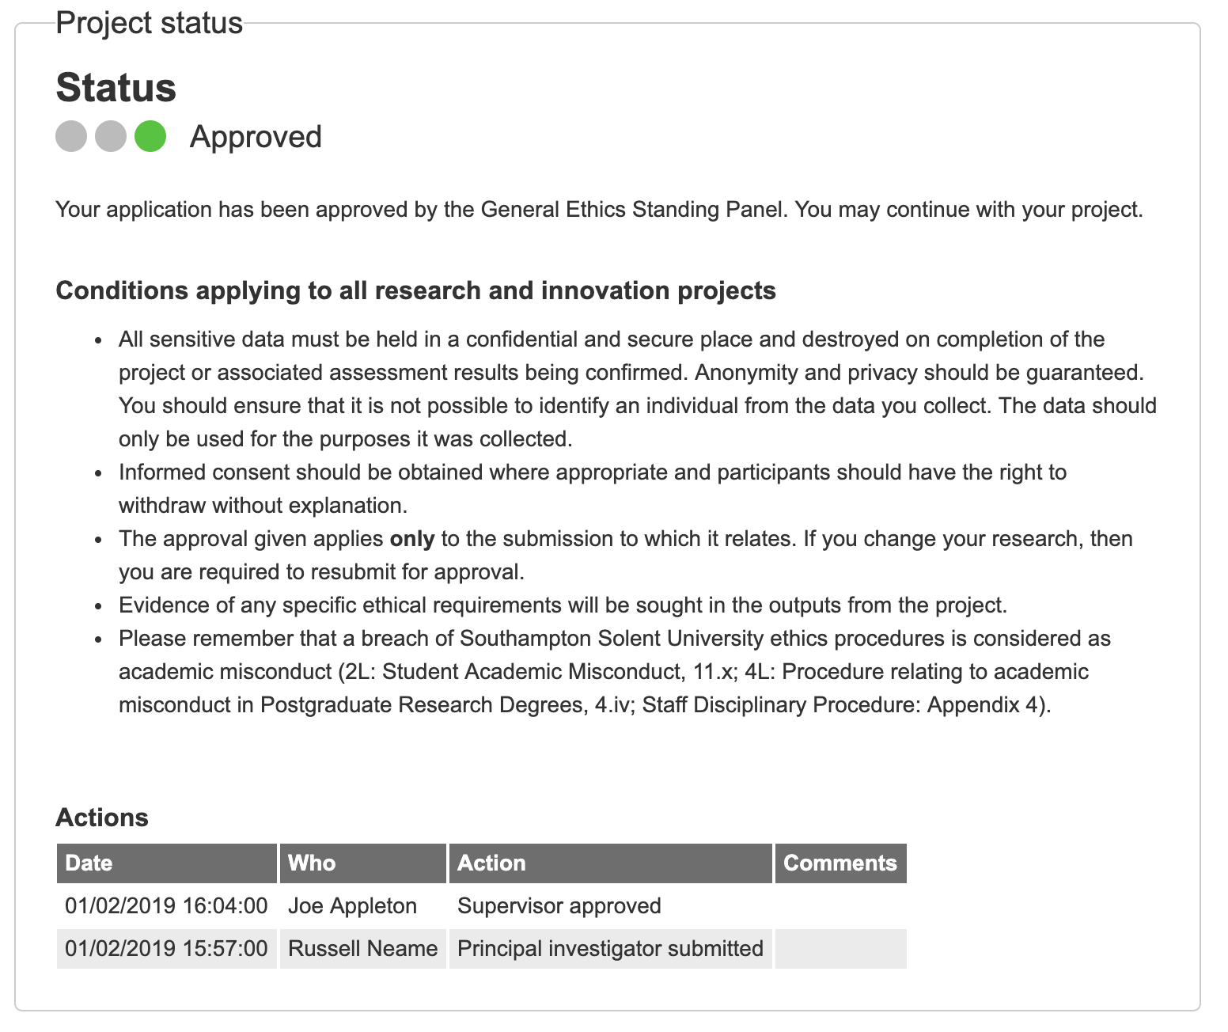

Figure 25 – Approval of ethical clearance at the start of the project

## 

## **Appendix F – Participant information sheet**

**Participant information sheet**

**Study title**

We would like to invite you to take part in our research study called “**In what ways can a progressive web application help raise awareness to university students on the latest scamming tactics**?”. Before you decide if you want to take part, it is important that you understand what the research is about and what it would involve for you.

Please read the following information and discuss it with others if you wish. If you would like any more information or if anything is unclear, please contact us:

Name: [Russell Neame] (Principal Investigator)

Email: 2neamr52@solent.ac.uk

Telephone Number: 07956274930

**What is the study about?**

This study looks into exploring the research title “In what ways can a progressive web application help raise awareness to university students on the latest scamming tactics?”. The project has been in progress from 19th November 2018 and will end on 3rd May 2019. The goals of this project are to complete a build of a functional progressive web application that helps display students scam experiences, warnings or stories and investigate how effective the application is as a platform at raising students’ awareness of different scams.

**Who will conduct the research?**

The only researcher who will be conducting this study will be Russell Neame, a Business Information Technology student at Southampton Solent university.

**Why have I been invited to take part?**

You have been invited to take part in this research because you match the criteria of being a university student.

**What would I be asked to do if I took part?**

• If you decide to take part in the research, you would be asked to:

* Participate in a usability test in which you will complete basic functions of the developed application.
* Participate in a one to one interview following the usability test.

Participants will be contacted through social media platform Facebook to arrange a date and time suitable for both the participant and researcher.

The date / time / location will be determined by the individual participant.

The estimated duration of this study will be maximum of 1 hour.

**What sorts of questions would I be asked?**

Participants will be asked questions about their experience of using the app, it’s features, what benefits it has and what improvements can be made.

**Would the interviews be recorded?**

We would like to record the interview using iPhone recording software so that no information is missed, and so that it can be analysed later in the project. Participants will be asked for this permission beforehand in the consent form completed by participants before the study.

**Do I have to take part?**

Taking part in this research is entirely voluntary, participants who agree to take part will be asked to sign a consent form which states that participants have the right to withdraw at any time without giving a reason.

**Can I change my mind about participating in the research?**

Participants are free to change their mind about participating in the research at any time, they can withdraw without giving a reason and would not be asked to explain their decision to withdraw.

It will be impossible to extract and destroy data that has already been processed if requested by participants after the research activity has taken place.

**Would my taking part in the research be kept confidential?**

All information which is collected about you or your business/organisation during the course of the research would be kept strictly confidential, and any information about you or your business/organisation which leaves Southampton Solent University would have your name and address and business/organisation name and address removed so that you or your business/organisation could not be recognised.

**What would happen to the data collected?**

Results will possibly be published in academic journals and book, presented at academic conferences disseminated to third parties including policy makers such as Southampton city council. The participant will not be identified in any report / publication unless they have given consent for this to happen. Participants will not be given the opportunity to review the results before they are published.

**What would be the benefits of taking part in the research?**

Participants can benefit from the possibility of increasing their awareness to different scams that university students face, which may be beneficial in the future when detecting scams.

**Would I be paid for taking part in the research?**

Through participation, participants may be able to increase their awareness of scams they may face in the future. No form of payment will be offered in taking part.

**Has the study been subject to ethical review?**

An ethics release form has been completed in order to follow Southampton Solent university’s ethics policy and procedures.

**Who should I contact if I wish to make a complaint?**

Any complaint about the way you have been dealt with during the study or any possible harm you might have suffered will be addressed. Please send your complaint to the person below who is a senior University official entirely independent of the study:

UG, PGT or PGR Student projects: Head of Student Achievement, Academic Services,

Southampton Solent University, East Park Terrace, Southampton SO14 0YN; 02382 013200

Staff projects: Chair of the Research and Innovation Committee, Southampton Solent

University, East Park Terrace, Southampton SO14 0YN; research.innovation@solent.ac.uk

## 

## **Appendix G – Informed consent forms**

### **Participant 1**

Figure 26 – Informed consent form signed by participant 1

### **Participant 2**

Figure 27 – Informed consent form signed by participant 2

### **Participant 3**

Figure 28 – Informed consent form signed by participant 3

### **Participant 4**

Figure 29 – Informed consent form signed by participant 4

### **Participant 5**

Figure 30 – Informed consent form signed by participant 5

## 

## **Appendix H – Trello board used to aid in managing the project stages**

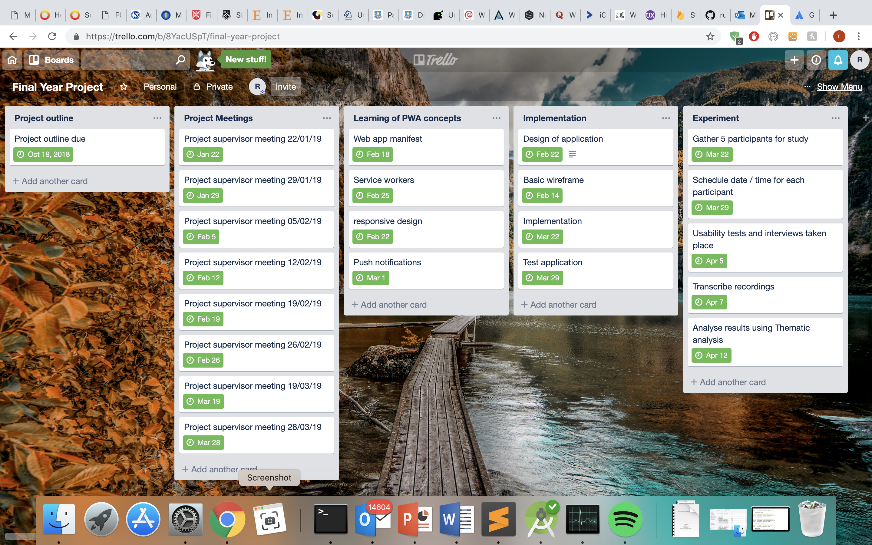

Figure 31 – Trello board used for management of different tasks throughout the project

## 

## **Appendix I – Planned hours vs actual hours worked during project**

|  |  |  |
| --- | --- | --- |
| **Task Name** | **Planned Hours** | **Actual hours worked** |
| Design, Research and Planning | 150 | 90 |
| Experimentation of concepts | 40 | 25 |
| Development of artefact | 200 | 180 |
| Testing | 40 | 20 |
| Usability tests and interviews | 40 | 10 |
| **Total hours** | **470** | **325** |

## 

## **Appendix J – Google’s Manifest requirements to configure a custom splash screen**

“

|  |
| --- |
| The name property is set to the name of the PWA |
| The background_color property is set to a valid CSS color value |
| The icons array specifies an icon that is at least 512px by 512 px |
| The icon exists and is a PNG |

**“** (Google 2019)

## 

## **Appendix K – Cross browser testing**

### **Google chrome**

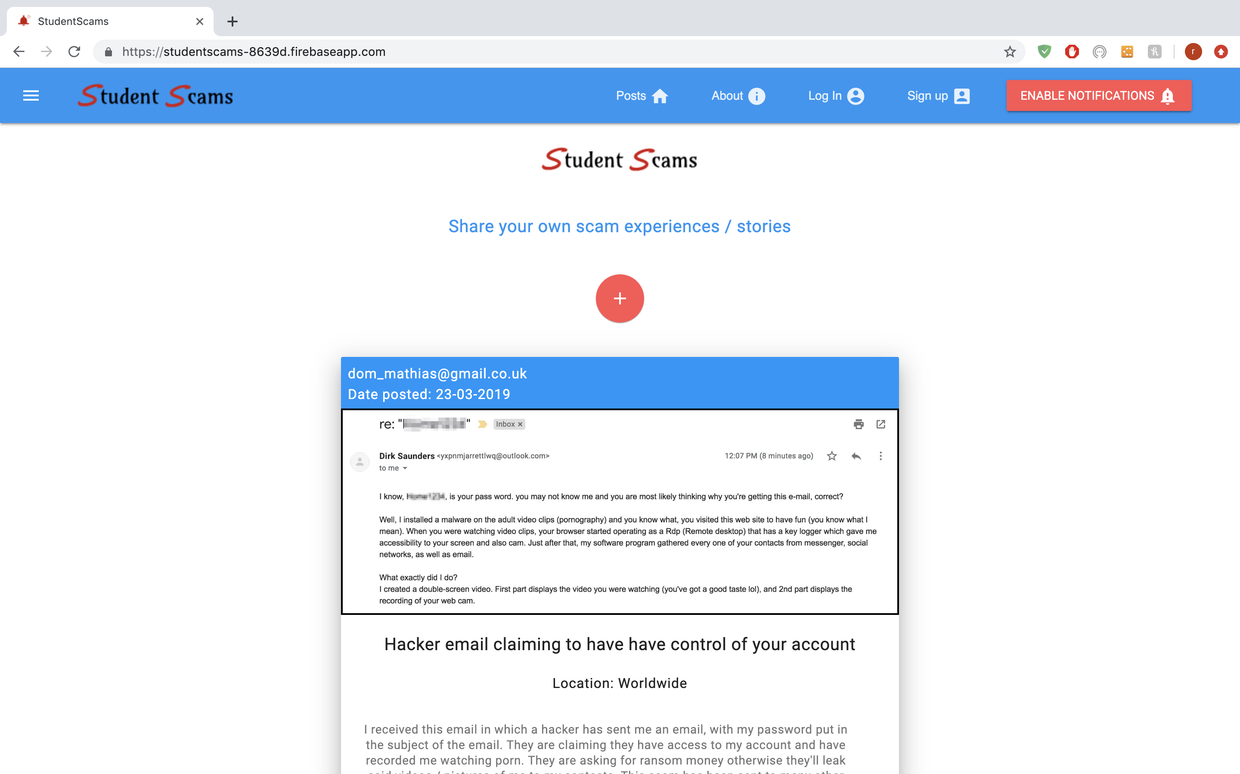

Figure 32 – Google chrome browser testing

### **Firefox**

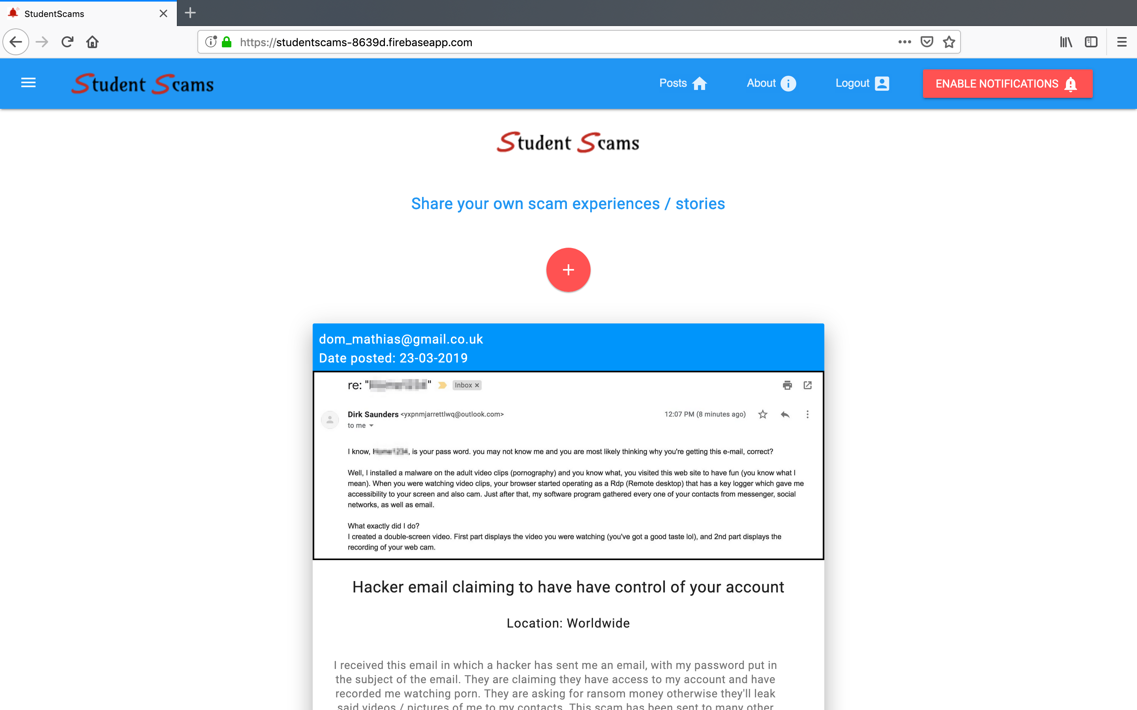

Figure 33 – Firefox browser testing

### **Opera**

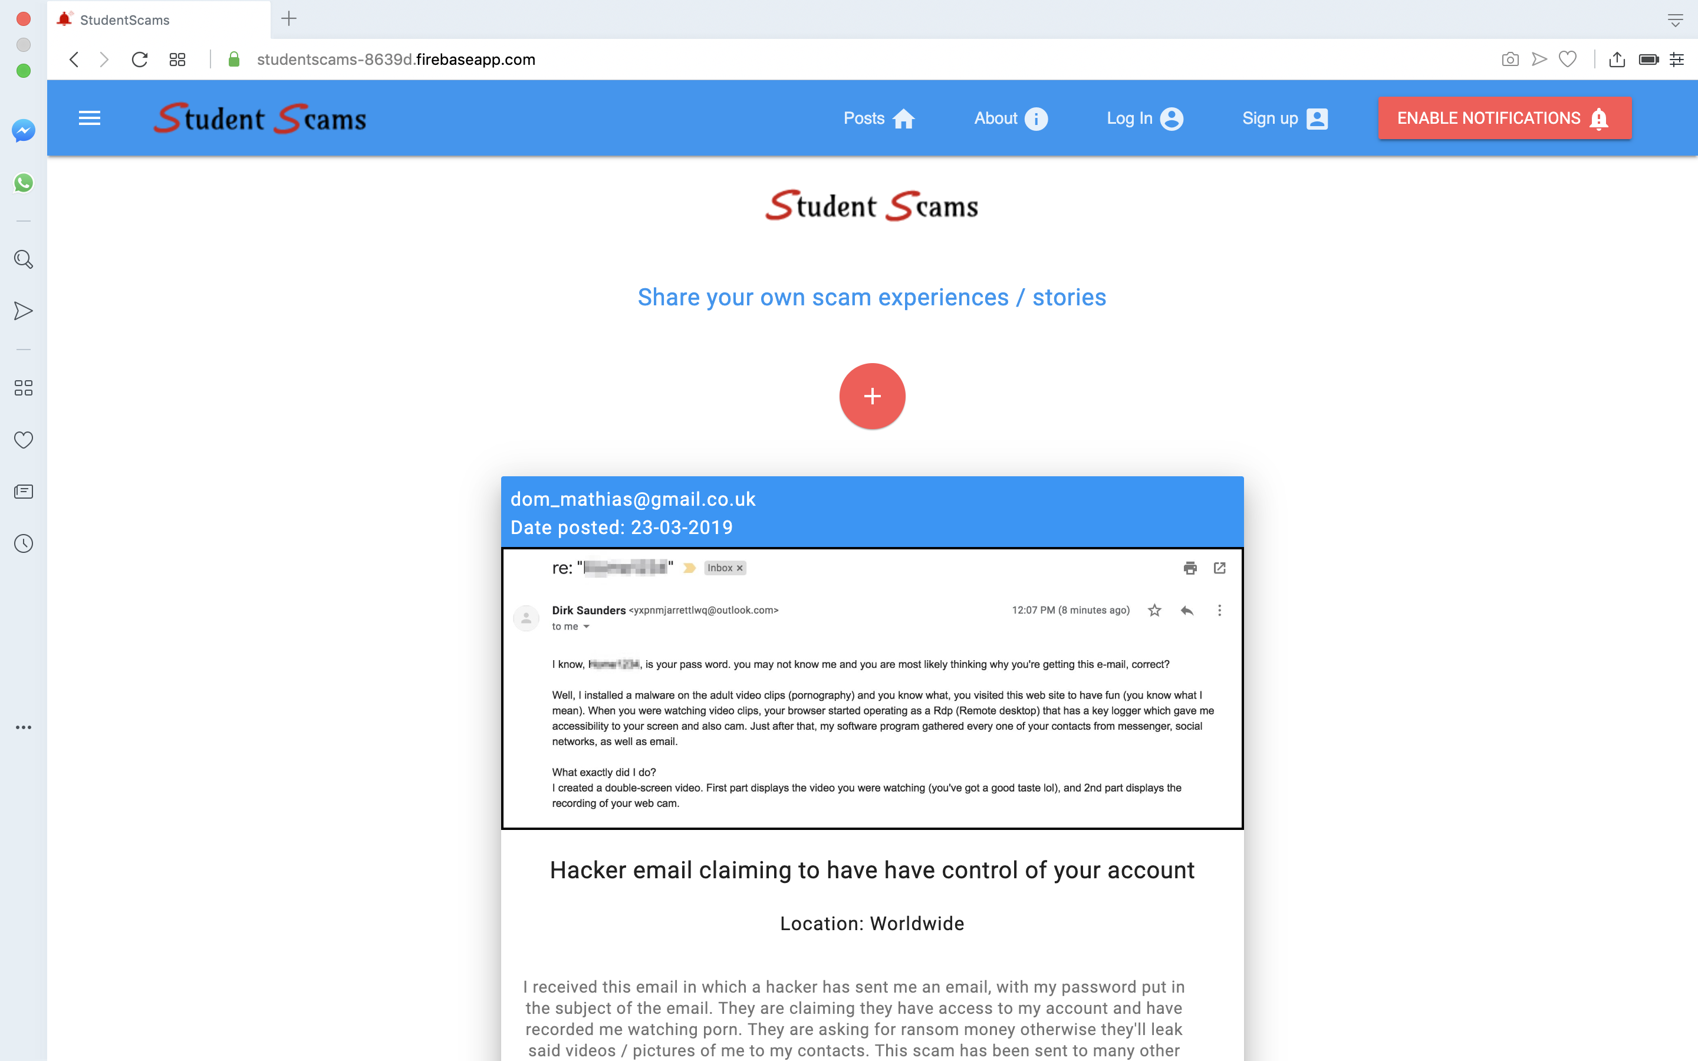

Figure 34 – Opera browser testing

### 

### **Safari**

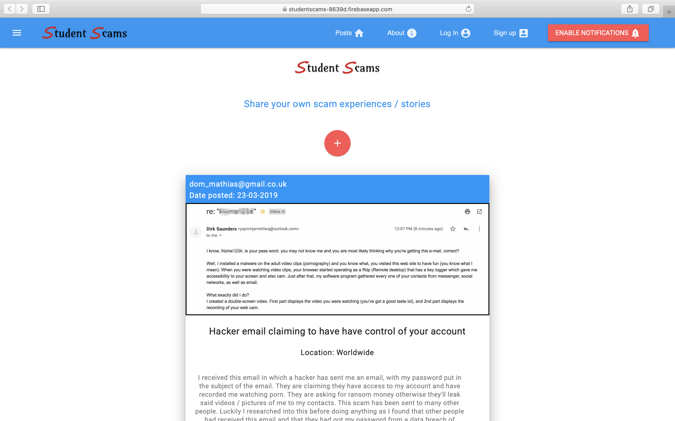

Figure 35 – Safari browser testing

## 

## **Appendix L – Device tests**

### **Mobile – iPhone 7**

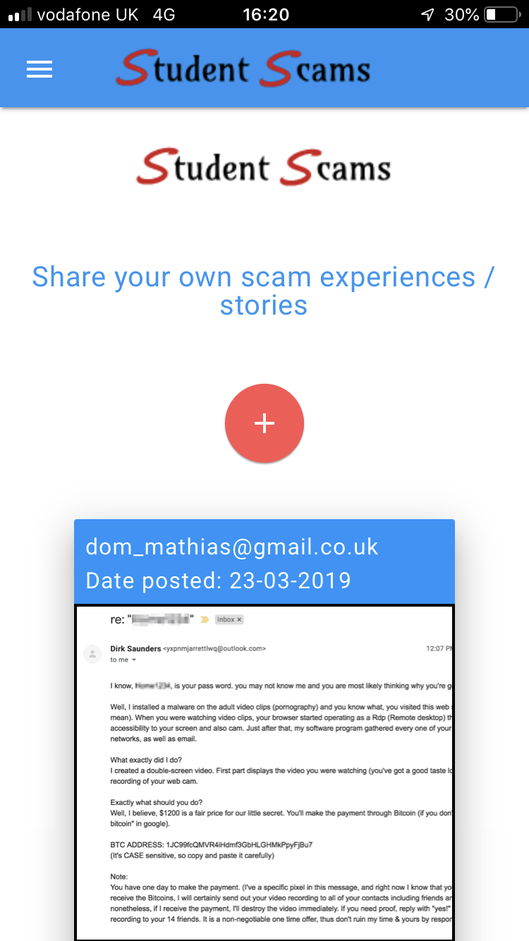 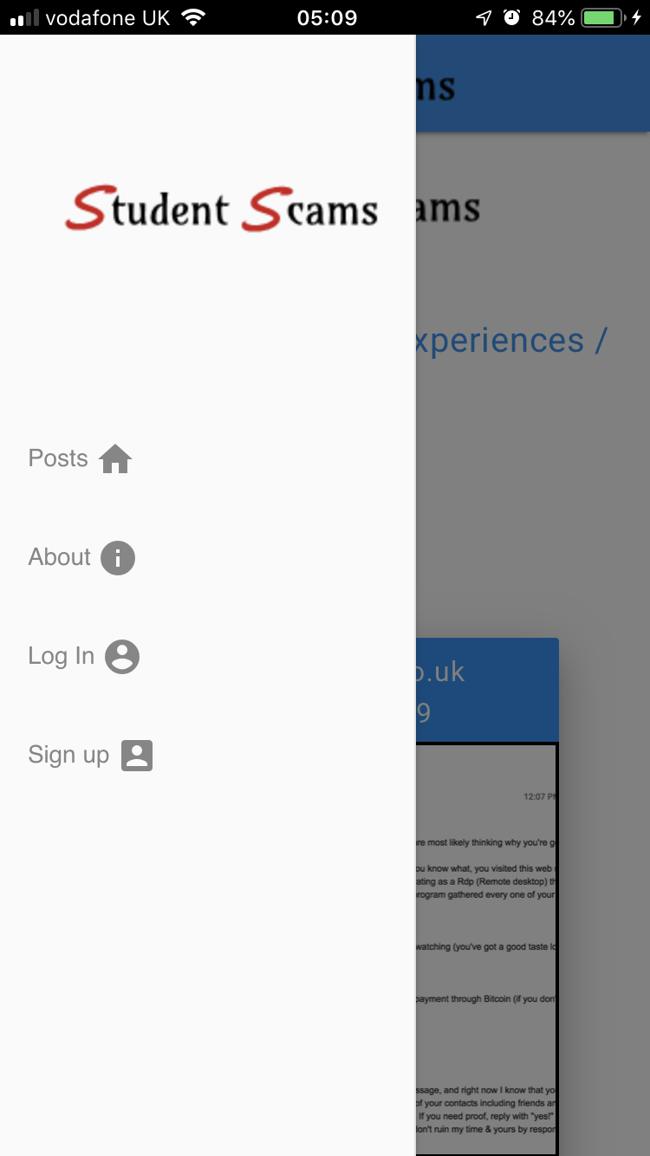

Figure 36 – Testing the application on a mobile device (iPhone 7)

### **Desktop – Macbook Pro 14inch**



Figure 37 – Testing the application on desktop (Macbook Pro 14inch)

### **Tablet – iPad Pro**

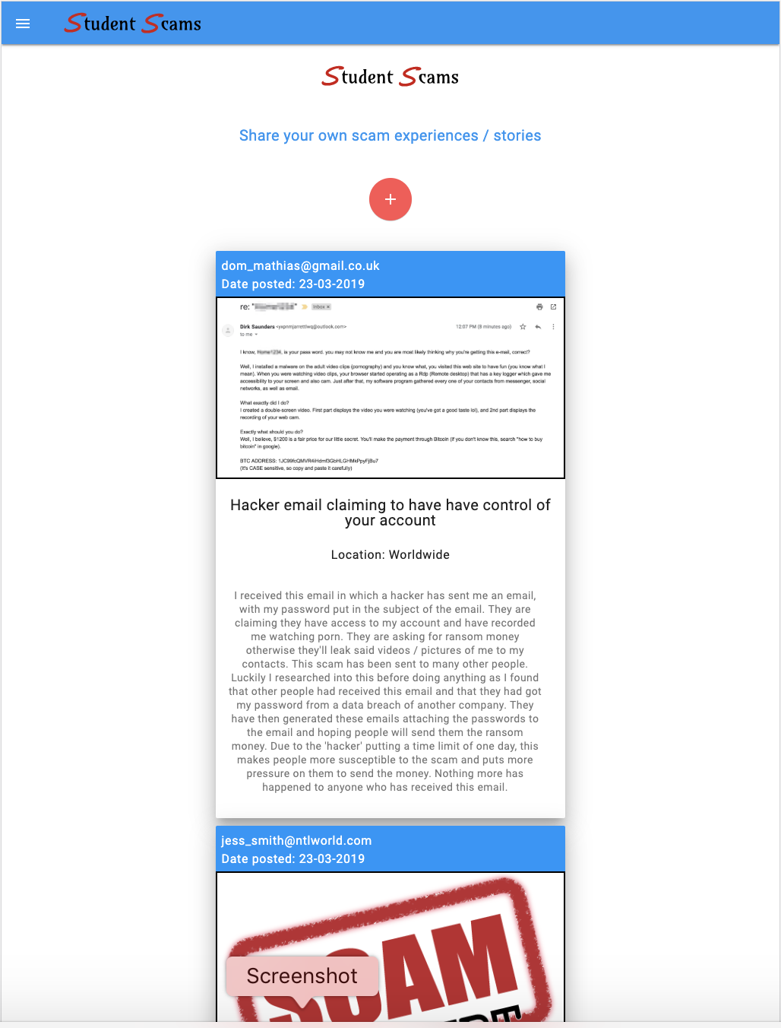

Figure 38 – Testing the device on tablet (iPad pro)

## 

## **Appendix M – Interview transcriptions**

### **Participant 1**

RE: so I've talked to you about what I’ve built, and all the questions will be around scamming, so I'm just going to define what a scam is... so a scam is a fraudulent scheme performed by a dishonest individual, group or company in an attempt to obtain money or something of value.

so the first question I’ll ask is have you been involved in any scams during your lifetime, if yes can you describe what happened?

vb: I kind of think... it depends how you define scam really because um... I feel like I’m being really stupid with these answers... I haven't necessarily been scammed online but I’ve been mistreated by companies or organisations… or I’ve had things stolen from me, so not necessarily from an online scam, but I have had weird things happen to me, I’ve had people claim to know my password.

RE: so things like that... what happened?

vb: so recently, I have 2 email accounts currently, but one of them is a new one I use on a daily basis, and the other one I don't check that often, but I checked that email quite recently and I had someone claiming to be Laura smith, who is one of my best friends, so it's clearly someone’s who's hacked into my something, found out who my friends are and has tried to get me to click the links in these emails from my friends, which is quite scary.

This doesn't involve me directly but at my last job I worked in CRM marketing, which resolves around email databases, and they had a data breach where someone was holding the company ransom, like threatening to… asking them to pay millions of pounds otherwise they'd email our contacts revealing everyone’s passwords.

RE: so next question, how hard / easy did you find this app to use?

vb: I thought it was really easy… the icons helped you know what each button does, and the whole idea of it is really clear.

RE: So with the scams that I’ve made you read through, did you know about any of them, and if so, which ones did you know about?

vb: Urm, I knew the landlord one, obviously because I’m a student myself that’s one that is pretty obvious, like before you get into student housing yourself you get it drilled into your head by everybody like “don’t trust landlords” “don’t trust estate agents” , so that one was pretty apparent to me.

I wasn't aware of the Chinese one, that's not something I think I would have known about.

RE: yeah, it may not apply to you but it’s a student scam.

vb: urm... yeah, so I know of the whole, like… I’ve seen it in documentary’s where people have had hackers tell people they've been watching porn, but it’s never happened to me personally, or anyone I know but I’m aware of the fact it happened... but definitely the student landlord one as its part of my life.

RE: okay cool, so with the one you said that you slightly knew... the hacker one in the email... do you reckon you could spot that yourself?

vb: it’s a weird one because... I don’t know if it’s because of my industry of work but it is something I know about, but maybe I don’t know about it as much as I think I do. For example I know that people hack emails, and tend to be a very basic email, or it tends to be a very weird email come up at the top but it’s quite obvious it's not your friend or the person they claim to be but then the fact they claim to be my friend is quite strange I’ve never had that happened to me before and I would have never expected that. It was never until my placement that I had someone explain to me about the process of clicking on a link from a dodgy email and how that sends over your details and i wasn’t actually aware of the specifics, so i don’t think you would know about that unless you were told specifically.

RE: okay so a bit of information given to you, sort of helped you?

vb: yeah

RE: okay cool… so when using the app what did you think of the layout of it?

vb: I think it had a really good clear layout, I liked you could click on the pictures as well so you could get a closer look of the examples, as it's all well explaining what the scam is but if you don't have photographic evidence it may not be that useful.

It did have a description, dates and stuff, and maybe it should have some chronological order to it.

RE: yeah it does actually have that…

vb: oh sorry! That’s just me not noticing it

RE: that's fine, that is a good point though so that's something you like on the app?

vb: yeah, so maybe with scams everything tends to happen to a lot of people at the same time, so maybe if it said these are all the scams that have happened in the last week or I don’t know… if it had something with a bit more order to it maybe I missed it...

the icons at the top were really good as they made it really clear in what you wanted me to do like finding the notifications and creating an account, urm…

RE: okay so with that, that brings me onto my next question... the next question is what positives can you list about the app if any?

vb: I think it was very obvious what you needed to do… it was very obvious when you wanted to create a new post, it was to click on the plus sign in the middle of the page. It wasn’t over complicated; it was a very standard structure... urm… that's it really.

RE: from the other side, what negatives did you find from the app if any?

vb: urm... maybe going back to what I said earlier about having.... because at the moment it got lots of different scams in one page, if it had a grouped thing, so maybe grouped different scams together, so if it was strictly landlords section

RE: okay so sections to it then such as landlords section, phishing sections...

vb: yeah because at the end of the day if you were scammed by your landlord and you went on here to have a look, you would want to be able to go straight to that, you wouldn’t want to look through other things that may not be that relevant to you

RE: so another question is what benefits do you feel this app would have for university students if any?

vb: I think generally university students are a vulnerable group I feel like I speak for myself as I am one, I feel like you're dumped into adulthood and you don’t have an awareness of these things that our parents might have, so we do heavily rely on things like this to tell us when things are wrong. I feel like with scams as well the only way of getting the word out there is awareness, and obviously word of mouth talking about it, so if you have a platform to promote it then that’s really helpful, you need something like this, I know we can talk about it on Facebook and share it on Facebook, however that's only limited to our friends and isn’t shared to everyone. Students don’t change, we all end up... there’s always going to be a flow of students going to university, so if there's something on there showing scams about landlords or scams with emails in the same area, then that's a really good way of getting the awareness out.

RE: are there any apps that you’ve used similar to this one?

vb: not really, to be fair this is probably me being a bit stupid but I think it's a really good idea but I’ve never thought of doing it much myself and I think that’s because I don’t really know why to be honest, I think maybe it because I haven’t had many scams affect me that badly, urm I’m quite aware of the online forums, and just general forums, maybe not scam specific, but sometimes I think if you have a specific scam happened to you, you would just type that scam into google, but the idea of having a generalised chat forum page is a good idea to me because it means you can look out for things that you wouldn't expect as well. urm... I can’t remember what the question was again?

RE: are there any apps that you’ve used similar to this one?

vb: I don’t think I have done, literally the only thing I can think of is standard social media where you just talk about it online.

RE: so if you are unsure / suspicious of a possible scam, what would you usually do?

vb: I tend to sort of ask people I know who are good with stuff like that, so I would tend to ask my boyfriend or my dad as I know they're good with that kind of thing, or I would type in the problem to social media like twitter using the hashtag to see if anyone has had that problem. or sometimes just googling it, sometimes all it takes is for you to type it in and someone else has gone through it. but then if that doesn't come up it puts you at ease and you think 'okay I'm overthinking it then'.

RE: so with that then, can you describe a time to me where you would use this specific app?

vb: I think student housing is a massive problem, I genuinely think, I know that they have a few laws trying to sort it out at the moment, but nothing can really prepare you for how badly you can be screwed over by landlords or estate agents when you’re a student, and I think this would be a really good way of highlighting that to new students and I would be happy to use it to... because I’ve had so many bad experiences of overpaying rent, my landlords walking in my house when they feel like it and it would be really nice to be able to tell... obviously students will be moving into this house in a few months’ time, it would be nice to tell new students quite openly, because otherwise they don’t get what they deserve(landlords) and could potentially get scammed. They need to have people standing up against them and putting it on the line, for them to be noticed and taken seriously.

RE: okay cool, so if you were unsure or suspicious of a possible scam, how would you use this platform to seek more information?

vb: urm... I guess... what so you mean like...

RE: so if you came across a dodgy email that you were suspicious about or a landlord you were suspicious about, how would you use this platform to get more information?

vb: urm... I guess it would just be to see if anyone is in the same position, and I guess it would explain the procedures of how they've overcome it or just going into more detail. because if it’s a small problem, this could show me that it’s a much larger problem than I thought it was. it puts more and more evidence together in a way, for example if I needed to contact the police.... as police don’t take things too seriously, but if I said 'hang on this has happened quite a few times' or saying this is proof that its happening more than once. Also, if people are happy to leave their emails on here as well and show their contact details then I would be able to contact them as well and actually ask them specifically for more details, so it brings a social interaction in a way where you can talk about it.

RE: okay so what features of this app could you see being beneficial for university students when it comes to scamming?

vb: I think... sorry my way of describing technology is really bad, but the part that means when the internet goes and you can still fill in your details is different to your competitors

RE: oh okay so the offline functionality?

vb: yeah so the offline functionality I thought that was... if you think about students and me personally my internet connection always dies, and imagine if it were a scam related to... I don’t know… the internet or something really stupid, then having that function would be really useful. Also students have to pay the least money for the worst wifi so I am so used to my technology dying on me all the time so it would be really useful to have that.

RE: last question.... what further features would you like to see from a platform like this?

vb: I can probably give you some small realistic examples...

RE: yeah so you've already said about the sections so I’ll take that into account but what other features would you like to see if any?

vb: I really like a whacky out there feature, which I wouldn't expect to see in an extreme version but a function that contacts the police directly... or maybe have a professional on there who gives advice, so maybe something that pops up like a chat box which pops up and says 'hi my names blah blah and I’m here to help you' so if you have any scams you can call this number.

But generally, I think smaller details like I said... grouping things together so people can navigate specifically to a landlord problem or email problem. because I think filtering it would really help narrow it down, I don’t know it's quite useful having all the different scams as you don’t want to disregard any as they're all equally important but i do think maybe having a filter at the top to help click on the scams that have a keyword

RE: sort of like a search feature?

vb: yeah they are all equally important and they do all have awareness, but it's just to filter it and group it.

RE: okay and last question, if there any additional information you would like to add?

Vb: no that’s it from me

RE: great, well that’s the end of the interview, thank you for your time.

### **Participant 2**

RE: so I've talked to you about what I’ve built, and all the questions will be around scamming, so I'm just going to define what a scam is... so a scam is a fraudulent scheme performed by a dishonest individual, group or company in an attempt to obtain money or something of value.

so the first question I’ll ask is have you been involved in any scams during your lifetime, if yes can you describe what happened?

rc: yeah so... my housemate recently got their PayPal account hacked into, so in that sense their details were being taken and used by other people. They did get an email from a fake PayPal saying you’ve received money please log in and they did it, so a few days later they saw money was drastically coming out their account. luckily, they'll get the money back but it followed from an email of clicking through a link which took them to a fake website to log in.

RE: so do they know how that happened then was it a dodgy email?

rc: yes it was a phishing email, where they made it look like a PayPal email saying you've received money, log in... and they did it unfortunately and then a few days later they saw drastic effects.

RE: cool, so I’ve shown you the features about the app and walked you through what I’ve built... so how easy or hard did you find the app to use?

rc: yeah it's fairly straight forward and fairly simplistic in design, it's fairly clear where everything is such as adding posts, enable notifications and login/logout so it's fairly straightforward and easy to use

RE: with the scams you read through on the app, did you know about any of those posted by the other users, if yes, which ones?

rc: yeah so I’ve heard about the student finance one, I’ve received this once or twice which look fishy so that’s relatable to myself. I know people that have received ones telling them that they have passwords to their email account, trying to spook them into thinking they have inappropriate content and that they’ve been exposed, so those are the 2 I’ve heard of before.

RE: okay so the ones you haven't heard of that student’s face are like the LinkedIn scam, such as job openings.

rc: no not really

RE: so the international students one, do you come across them much?

rc: no I can’t say I do particularly

RE: okay so what did you think of the layout of the app?

rc: Yeah it's good how it's similar from app to mobile, so it doesn't look any different so you should be able to use it the same way. The colour scheme makes it very inviting, and the text / fonts are very clear. Its good how you can add a picture with the text below it to explain the scam, I think it works very well how it's a list full.

RE: okay, what positives could you list about the app itself if any?

rc: I’d say it’s very clear, easy to use which I've said before, I think it’s good how you can look through it and you know where it's happened, you know what it's to do with from the title, so you can save yourself reading through it so yeah I’d say it’s really straight forward which works in its favour.

RE: cool, and just against that then, what negatives did you find from the app if any?

rc: the only thing I would say is...not so much a negative but something that could be improved on is that it could have a search feature so that if you were looking for a specific scam that's happened to you or anyone else they could search and then if something with a similar title comes up they can go straight to that post rather than having to scroll through having to find it.

RE: cool, so what benefits do you feel this app would have for university students if any?

rc: so obviously uni students aren’t the wealthiest types of people, so if something like this happens where they get scammed out of money it can hit them a lot harder than it would hit other people, so obviously by raising awareness like this app does of what other scammers are doing, as students are being targeted and it is good that other students know what's happening, so yeah I guess by raising that awareness it does help and people will benefit from it.

RE: okay cool, so relating to this app, have you used any apps similar to this?

rc: I wouldn't say I’ve used any apps on mobile or websites, but what I would do if I suspect somethings fishy is do a quick google of the text inside it, and see if I find any different forums that are known specifically for students in scamming and yeah... just try and see if it has happened to anyone else.

RE: if you were unsure / suspicious of a possible scam, what would you usually do? i know you said you'd google stuff as well, is there anything else?

rc: so I’d probably google to see if anywhere else received it, I think a really key one as well is to click on the contact of the email sender, and look at the email, this can tell you a lot about if it's verified. Even if it does look very similar, you can just google that email address and see if it links back to the website, so I think trying to make links to what is legit and what’s not.

RE: is that when they mask the email?

rc: yeah so when student finance send you an email, and you click on the address and it comes up with 00..

RE: okay, can you describe a time where you would use this particular app in day to day life?

rc: I've once or twice been hit with student finance ones where it looks like an email been sent from them or PayPal... I think I’ve had one that looks like it’s come from my bank, but when you look further into it, it's not so obviously by raising awareness that these are the companies being used, and this is the information being given then I would try and share my ideas / what's happened to me with other people to make them aware as well.

RE: okay so say that situation with the dodgy bank email, if you had that what would you do with that with this app?

rc: yeah I’d probably take a screenshot of what’s said in the email, then explain that I don’t think this is from my bank, I would probably ring my bank to confirm, and then share that information if it's not true or not real with your website.

RE: cool, so if you were unsure / suspicious of a scam, how would you use this app?

rc: I would go on the app to see if anyone had posted about it or look for similar type of emails but if there wasn't anything then I’d probably make a post for myself to let everyone know of my experience I’ve had with the scam.

RE: what features of this app could you see being beneficial for university students when it comes to scamming?

rc: so obviously you've got a notifications part so that when a new post is added it pops up on your laptop which I feel is beneficial as you don't know how regular things are happening, but it would take you 2 minutes to have a quick read through and see if you can relate, or it would give you the knowledge in the future that this is what happens if you do get something like that you can just flag it and put it in your spam. So yeah the enable notifications button is quite useful.

RE: so I showed you the features of the app, what further features would you like to see.. I know you've mentioned the search, are there any more?

rc: yeah I think a search option just so that if you experienced something, instead of having to go through all of the posts, you can then just click on it and search it, if no results found then you can crack on and write your own one.

RE: yeah so if you had a landlord email you can just search this and the landlord posts would come up

rc: yeah

RE: last one, do you have any additional information you want to add?

rc: nope I think I’m all good.

RE: cool, thank you very much for your time.

### **Participant 3**

RE: before I go into the questions, I’ll define to you what a scam is... a scam is a fraudulent scheme performed by a dishonest individual, group or company in the attempt to obtain money or something else of value.

RE: cool, have you been involved in any scams during your lifetime, if yes can you describe what happened?

tp: I haven't been scammed, but I’ve been involved in it, but I wasn't the person talking to the person. so recently, 3 weeks ago there’s a ticket scammer on Facebook, this is for hybrid minds, me and this guy were looking to buy 2 tickets, and this guy said he can do two tickets for £25, but basically the mate who bought the ticket, he went through PayPal friends and family, and basically he never gave him the tickets. he actually ended losing the money as I didn't pay him my half as he said if we get scammed, he'll pay for my half.

RE: so, he did get scammed in the end, and lost out of money?

tp: yeah, he lost out on £25, and then that night whilst we were there, we were telling people about it, an told my brother the person’s name, and he said someone made a Facebook post about that person the night before. But me and Charlie never saw the name. But when we searched the person’s name in that Facebook group, 4 other people made posts about this same person.

RE: so I guess that's one thing, if you knew about that the night before...

tp: yeah it was annoying how we didn't know

RE: so next question, how hard / easy did you find this app to use?

tp: it was extremely easy to be honest, everything is in the place you would expect it to be, so obviously the nav bar having no drop down makes it easier to know what's where, so you don't need to go searching in the top.

RE: cool, so with the scams I’ve shown you and you've gone through yourself, out of those ones, which ones did you actually know about, or did you know about any of them, if so which ones?

tp: (scrolling) are we talking about the type of scam? so like... student finance scams?

RE: that exact scam, so not all phishing scams, but that exact type of phishing scam...

tp: I feel like I’ve definitely heard of the student housing rental ones, I've definitely heard about that being talked about before. I haven't heard of the LinkedIn one before, I've definitely heard of this... the email one claiming to have the control. I actually knew about this one by being subscribed to people on YouTube who get their own back at scammers and this seems to be a pretty common one, they receive emails like this, and basically ring them back and basically hack them back.

RE: okay so these other ones... what about the Chinese student scam? I guess it applies more to international students but is that something you've seen before?

tp: not really, I don’t really know many people who have come from overseas so I’ve never had a chance to speak about that kind of stuff, but I can see how that would be a popular target.

RE: what do you think of the layout of the app?

tp: I think it's all good to be honest, I don't have many comments about it really, I don't have any faults with it. Are there other questions about how I change it?

RE: yeah later down the line, but if that's it that’s fine...

RE: so... yeah, what positives can you list about the app?

tp: I think the way you post different scams is very simple which is good, obviously the deleting function is good so you can delete your own. Oh, and the notifications, I’m impressed with that.

RE: so, on the other end, what negative can you point out about the app?

tp: I’d say when it comes to these big blocks of texts on the posts, if you were to start scrolling, you've obviously got the heading that says briefly what it is about, but I don't know if the poster (user) would want to write any more than they do... but having a brief description that's like a couple of sentences long, so you get the option to read the whole thing, or read a quick snippet of it.

RE: okay, so sort of like an expanding section?

tp: exactly, just something you can read quick and think 'okay this is something I can relate to, let me read the rest of it'. because otherwise you're hit with this massive block of text and think 'I’ve got to read this whole thing' and if there’s lots posts you would be scrolling for a while. So maybe what you said an expanding section which shows like 5 lines...

RE: I think that's a good point, so something where they add a brief description, as well as the content so that can attract users to open and read it... is that what you meant?

tp: yeah so "i nearly got scammed for £300 because someone stole my email, password, claiming they have control"... that's a brief description which tells you what it is, how much they stole and yeah that’s one-way I thought you could do it.

RE: okay cool. What sort of benefits do you feel this app would have for university students if any?

tp: well obviously it would help them not get scammed and they would see the type of different scams, as I have only heard of half of these ones that you have on the app, I had no idea you can get scammed through LinkedIn, I wouldn't have guessed they did so that does raise awareness to different methods. You're used to hearing about typical email ones... but you don't really hear of many others. So, it's good to raise awareness about that and also not just the types of hackers but the emails it comes from... or like the people or names of the people is shown which is good.

RE: okay so like the examples?

tp: yeah so like this name here *points at image on hacker email scam post*, or the email that sent this shown in the picture is good to see the names of the scammers which you could keep in mind for the future.

RE: have you actually used any apps similar to this one?

tp: i haven't no. I’ve never felt like I’ve had to as of yet. But nobody's really ever approached me in scamming, using scamming tactics, so I’ve never really had to, but if someone looked like they were legit enough but I was still wary of them, then I would have a look, or google someone’s email address.

RE: okay, so if you were unsure / suspicious of a possible scam, what would you usually do?

tp: it would be to just stick it on google, type the email address, or I guess if nothing came up, I may go further and look for different sites and then have a look on them. but I haven't had to yet but that would be my first go to.

RE: okay, so can you describe a time where you would use this app?

tp: if I or anyone else wasn't sure and asked me about scamming, I guess I would search for them as well, so if a family member like my mum or my dad weren't sure, they would probably put in the group chat 'does this look weird to you?' and I would look into it for them, so I would use it then or for myself.

RE: okay, so if you were unsure / suspicious of a possible scam, how would you use this platform to seek for more information?

tp: I think I’d quite often use this app to be nosey, to see like how other people have been scammed. I think it would be quite a good read as bad as that sounds... reading other people’s misfortunes, but other than that it would be interesting to see different ways. I’d probably just read it every now and again.

RE: what features of this app could you see being beneficial to university students when it comes to scamming?

tp: I suppose the notifications, they could be. Also the different ways to upload a picture is good, so taking your own picture or uploading it, so having those two options is good. As not everyone wants to take a screenshot on their laptop and send the picture to their phone if they're wanting to post on their phone, it's easy to just use the camera.

RE: what further features would you like to see from a platform like this?

tp: so, a search functionality, just to make the whole process slightly quicker. A Categories option, so a view by categories, so view by email phishing, view by student housing rental... just so you can filter out ones that really aren't relevant to what you're looking for. Say if I was approached by an email hacker, I’d only want to see email ones. Also commenting would be quite cool, or even like an in-app chat, so if I did... is this app solely used for people who have been scammed, or people who are thinking they're getting scammed?

RE: it’s both, so for all stages of it. Say for example you’ve been scammed, so you can post that story to warn others, it could be in the middle of one where you look at something and you're unsure so you check on this app to read other stories to increase my knowledge through that, and then just for having a general read through to keep your knowledge up to date.

tp: so I think you've got the email address of the person who posted it, so you can get in contact with the person who posted it if you want, but a small comment section beneath, like Facebook commenting, to get quick feedback and I’m sure that would go well with notifications. it would make it quicker as a lot of people I know don’t check their emails very often, say if someone was to say 'I’ve been approached by the same person' it might be too late by the time they reply. Also, there could be some liking / upvoting but I don’t know if that would be beneficial, I’m just thinking of other platforms that use it. other than that, that’s it really.

RE: okay cool, so last question, is there any more additional info you'd like to add?

tp: I think that's all to be honest.

RE: okay well thank you for your time.

### **Participant 4**

RE: I've showed you round this application, so I’m just going to give you a few questions about this app and scamming in general. So I’ll just define what a scam is first... a scam is a fraudulent scheme performed by a dishonest individual, group or company in an attempt to obtain money or something else of value… okay cool so have you been involved in any scams during your lifetime, if yes can you describe what happened?

matt: I don’t think so to be honest...

RE: okay, well have you heard of any scams that your friends have gone through?

matt: no they seem to be quite careful

RE: okay, well is there a scam that you've faced in which you've known it was a scam and disregarded it?

matt: yeah so when you get those emails through from Sky or BT, and it says 'You need to pay your bill, click here' and you hover over the click here text and it shows it's not a sky website, it's some dodgy completely different email instead of an actual recognisable address.

RE: okay sounds like a phishing email scam. So how easy or hard did you find this app to use?

matt: yeah it was quite simple, it was quite easy to work your way around, there’s not many different places you have to go to get everything. Everything is either displayed on the top navigation bar, or the side navigation.

RE: okay cool, from all the different scams you've read through, did you know about any of them? if so which ones?

matt: I've heard of the hacker email one about taking control of your account.

RE: okay so that's the only one you heard of before?

matt: yeah that's the only one.

RE: okay cool, what did you think of the layout of the app and how it is all presented to you?

matt: it's quite easy on the eye, I think the only thing which was annoying was clicking on this(image) which makes it really stretched out, but that could be how the image itself is. It was just a bit of a shock really.

RE: okay so making it a bit smaller would be better for you?

matt: yeah so it can zoom in if I wanted to see it easier

RE: okay, so what positives can you list about the app if any?

matt: it's easy to get around, it's easy to read what each scam is, everything is in date order so it's quite easy to see what the most recent ones are so you can get an idea of which ones are retired / older scams that aren’t used anymore. It's quite simple, there’s nothing over the top and extreme on it which may make it quite difficult to use.

RE: okay, so on the other side what negatives can you list about the app if any?

matt: not really, it kind of shows everything you need to know, like where it all is, and it shows what's most recent. Maybe including an archive page or something could be useful so you can see if old ones come back again but that's it really.

RE: okay cool. So what benefits do you feel this app would have for university students if any?

matt: well it means if they do get some dodgy email they're not sure about, they can check it up and search through to see if it's something going round, either locally or even the country as they're quite easy to spread.

RE: okay, so are there any apps that are similar to this that you've used before?

matt: no not that I’ve used

RE: if you were unsure / suspicious of a possible scam, what would you usually do?

matt: I’d either google it or ignore it... like copy and paste the subject into google and scam with a question mark on the end and see what comes up.

RE: okay so are there any sites you would usually go to for that?

matt: I’d normally just see what pops up first and see what comes up in the forums. There’s always someone who posts about it.

RE: okay, can you describe a time where you would actually use this app?

matt: if I were to get an email through which I wasn't too sure about, I would probably look on here (studentScams) and see if it is something similar that someone else has received. It would normally be through emails and messaging on Facebook which I think is where I would get caught out if I were to get caught out.

RE: okay cool. If you were unsure / suspicious of a possible scam, how would you use this platform to seek more information?

matt: I would go through each post and see if there were similar emails from maybe different companies, which could mean it could be more of a widespread thing and if it's very similar wording or similar amount of paragraphs or forcefulness then I would probably assume it was a scam and then ignore it.

RE: okay so what features of this app could you see being beneficial for university students when it comes to scamming?

matt: Mainly the list of posts, its ordered and makes it a lot easier for students. The notifications are good for when a new scam pops up and your phone buzzes and says be careful of this scam.

RE: okay cool, what further features would you like to see from a platform like this?

matt: comments underneath, where people can say 'this is something that happened to me'. And maybe a general search function, so when there is quite a few posts on there, you can search for key posts.

RE: okay great, is there any additional information you want to add?

matt: nope that is all from me.

### **Participant 5**

RE: first of all, I’m just going to define to you what a scam is... a scam is a fraudulent scheme performed by a dishonest individual, group or company in an attempt to obtain money or something else of value

RE: okay cool, have you been involved in any scams during your lifetime, if yes can you describe what happened?

sb: yeah so I have, upon my arrival in Renne, I was looking for an apartment, in the meantime I stayed in an air bnb. I joined a Facebook group to look for a roommate / somewhere to rent and I received a message from someone in this group, they said they lived in Switzerland and said their lawyer will get in touch with me. This lawyer said I must send him 800 euros of trans cash vouchers, which is a code you get at a newsagent, and you use this code online to transfer cash. I did that and there was no apartment to offer, I went along with it as I was desperate for an apartment... so yeah. I found out that this guy was fake, using the name of an actual property lawyer in Paris. When I contacted the actual lawyer asking what is going on, he replied saying sorry I don’t know who you are or about this situation. So yeah, the fraudster had taken the name of an actual lawyer.

RE: okay, so my next question is how easy or hard did you find the app to use?

sb: I thought it was very simple to follow, the screen itself is not cluttered when you look at it. It's simple, such as the big plus sign which is clear that’s how you add a story. Yeah it was very simple to use, I enjoyed it.

RE: okay great, so when reading through the different scams, did you know about any of them, if yes, which ones?

sb: I've heard of similar ones to the first one which is like 'I’ll send this to your friends / ill shame you' kind of thing, maybe not the exact scam specifically but basically blackmails.

RE: so you've seen the one about having control of your account one?

sb: yeah I’ve seen similar scams to it but not that exact one

RE: okay so all the others would you say you haven't seen?

sb: Nope, the student housing rental scam is vaguely similar to my experience, but I don't really know any of them.

RE: okay cool, so what did you think about the layout of the app?

sb: it's very similar to use, it's clear that you’ve got the post section with the posts you want to look at, it's got an about section which tells you about the app, the personal aspect with login / logout. it's simple to figure out, my mum could use it so that’s a good sign. There could be a different way to display the posts instead of in a big list? maybe a way of categorizing them, some kind of theme.

RE: okay great, what positives can you list about the app?

sb: The fact it looks like an app, and a website is good. The dropdown menu makes it look and feel like twitter how it's in the top left, which gives you the options with your account... it's a similar thing. It kind of moulds the website and app feel together quite well.

RE: cool. what negatives did you find with the app with any? I know you said about the posts being displayed better...

sb: it is a little bit bare boned, maybe some added design... I know it's not meant to be completely amazing but maybe having something a little more on the screen but I can’t figure out what it is...

RE: okay so something to fill the white space?

sb: yeah maybe that could be linked to the layout... but then again you don't want to overdo it as it's good that it's quite simple.

RE: okay cool, so what sort of benefits do you feel this app could have for students if any?

sb: Maybe towards the lead-up to a freshers time, where there's lots of foreign students coming over to England who don’t have as much knowledge, they may not speak any English at all, so maybe having something like this available to them to say like coming here, you're in a new country there might be people who want to take advantage of you... so look out for these things... and then the university could employ this app in that kind of way to help university students out... or anyone really. Freshers who have missed out on halls or something, say if their parents don’t take charge and they're desperate for accommodation, they may believe anything.

It's not social media, but it's got that tint to it as it's quite comforting to read other people’s stories...

RE: okay cool. have you used any apps similar to this one?

sb: not in terms of its goal no... it's quite a niche thing, quite a useful thing... I can't say there is no…

RE: okay cool. so, if you were unsure / suspicious of a possible scam, what would you usually do?

sb: well if I take the example of PayPal links and stuff on emails, if I was offered a link I would hover over it to see where it actually comes from. so, you can tell if it has loads of numbers / symbols and letters you can tell it’s some kind of scam. Urm, inconsistencies in grammar I look out for, poorly formed sentences, demands for information that you wouldn't normally get, with a sense of urgency. That's something that happened in my situation, they were like "I'm coming down from Paris now, I’m not making the journey from Renne to Paris so if I could get this from you now..." and that should have been a massive red-light.

RE: okay so your method is to pick it apart itself, by looking out for thing like that?

sb: that’s what I do now... ever since the scam.

RE: okay cool, can you describe a time where you would use this app?

sb: if I was suspecting I was being scammed first of all, I would look through to see if anything matched what I was suspicious about. Or if I had been scammed, and I wanted to warn others. Or just reading up the posts in advance if I was extra cautious.

RE: okay so just reading in your spare time?

sb: well yeah, if I knew I was about to become a fresher, if someone sent this app to me this would be good to read just to be sure.

RE: okay cool, if you were unsure / suspicious of a possible scam, how would you use this platform to seek more information?

sb: I guess I would just read through all the posts and try and figure it out.

RE: okay fine, what features of this app could you see being beneficial for university students when it comes to scamming?

sb: I think the whole push notification could really help, as it helps keep students up to date. I feel like it’s the type of app where you’re going through a scam, or you're anticipating that you're going through a scam then you would go to use it. In terms of push notifications, they will help build awareness progressively, so if they saw a notification for every post added and read it, they would build up an ability to detect different scams.

RE: great, so what further features would you like to see from a platform like this?

sb: Maybe added categorisation of the posts, so if it was a blackmail post it would go in that category etc... like some kind of index. Also maybe links to places where people could get help, like… not police as that’s a bit too simple but useful sites to help you take the next steps if you have been scammed like support lines.

RE: cool, would you like to add any additional information?

sb: I think it's good, it fulfils its function very well, it just needs a bit more fine-tuning.

RE: okay great, thank you very much.

1. <https://github.com/jakearchibald/idb>